Study of infantry construction
Before efforts at animation, frame hierarchy needs to be organised as per the game’s existing models.

“root1”
The first frame to be created in the hierarchy appears as “root1”, which corresponds to vertices making up a belt or equipment on it. Most of the time, but not always, the origin point for that object is at the ground
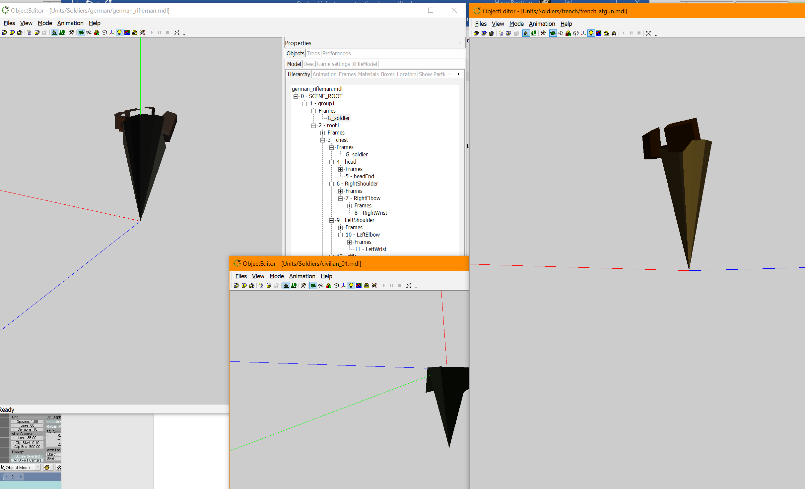
Within the hierarchy, it contains an instance of “F_soldier” (French) or “G_soldier” (German)
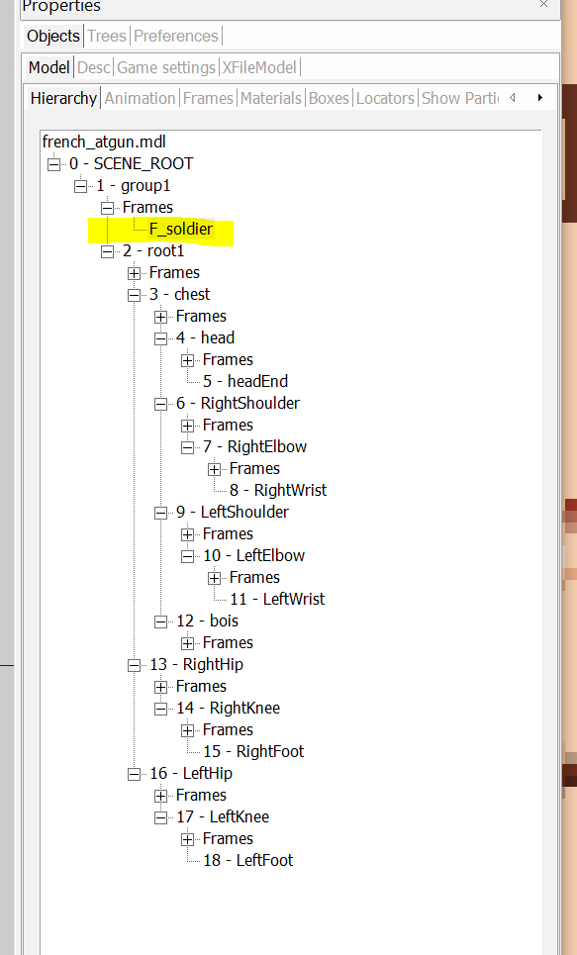

“Soldier”
The hierarchy has the “F_soldier” part repeating in it, yet when we look at the frames, we see this
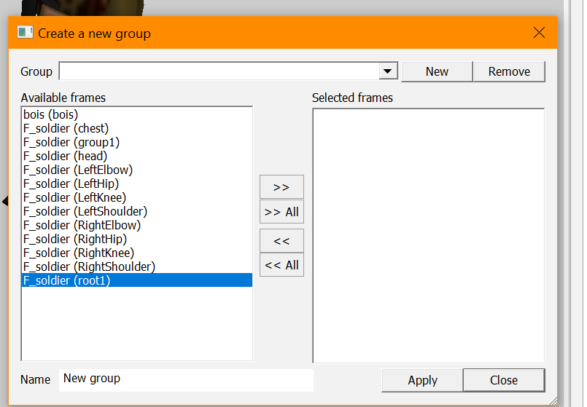
We can see that the frames don’t cover everything in the hierarchy
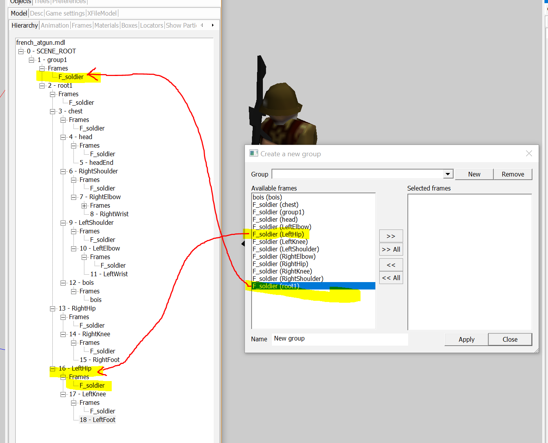
What exactly these parts of the hierarchy like “headEnd” refer to isn’t clear; them being classed as frames implies that they are objects, but inability to select them makes it not possible to view them. It is possible to see the origin point for them.
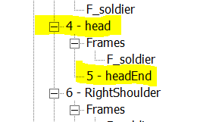
Created “French_atgun_in_review” as a means of studying the infantry model, breaking all groups down into the frames:
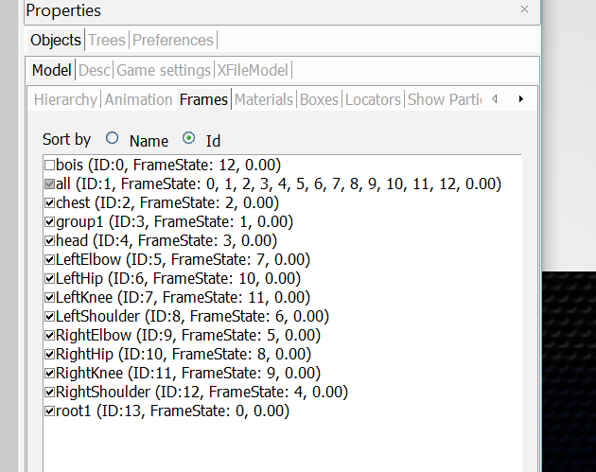

“Group1”
Interestingly, “group1” points to nothing but does have an origin. The best explanation is that this is the case with frames set in Blender that do not appear in the list and only their origin appears in the Object Editor. They are created in Blender, probably duplicates with a different origin point set (for example, “headEnd” may be a carbon copy of “head”, yet with its mesh deleted and its origin still there). Another possibility is that they are made by simply having an origin point in an object in the hierarchy, and there is no mesh)

Different orientations appear to be set with origin points
This likely is done via a rotation only in object mode in the editor, after orienting the part correctly already in the edit mode?
Whatever such sequence is needed, it can likely be tested if found necessary.
With head and headend, we see that the directions it uses are different in the Object Editor:
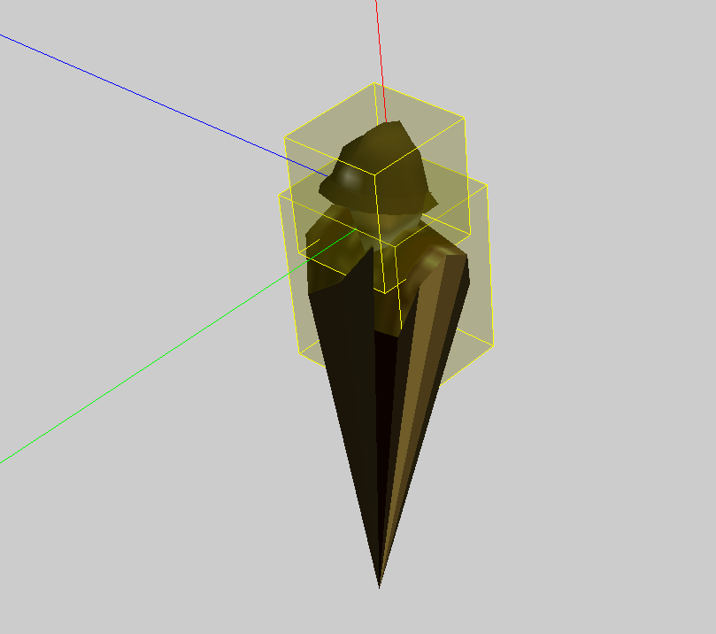 “head”
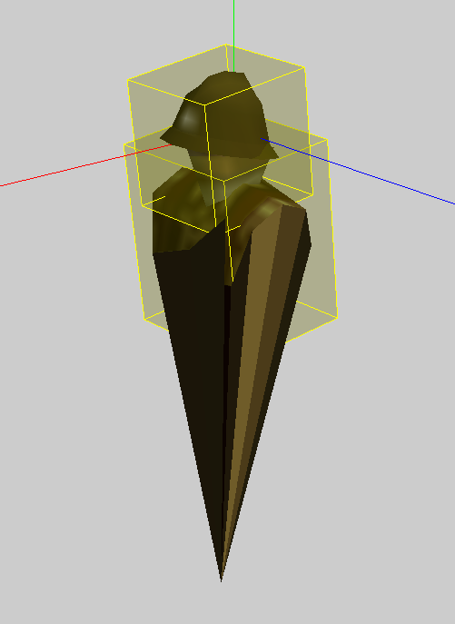 “headEnd”
“headEnd” origin directions use an orientation more familiar to the vehicles
This difference is similar to a disruption that occurred during earlier errors with vehicles, indicating it can be set somehow
Evaluation of what direction is being used shows that there is no particular pattern other than it holding a line consistent with where a bone would be

Getting parts to face different directions
A possible conclusion about this discrepancy in directions above is that moving the “object” in object mode in Blender to a different orientation causes this realignment, and that moving the object to parent causes the vertices to reset to their positions from edit mode. It can be subjected to tests until a good result is found.

Possible irrelevance
Whether through testing or results of creating an animation hierarchy, it may be found that the above concerns are irrelevant and that various elements in the hierarchy arise due to the use of armatures and so on, in keeping with Blender’s features

Discovery of an artifact relevant to understanding the process
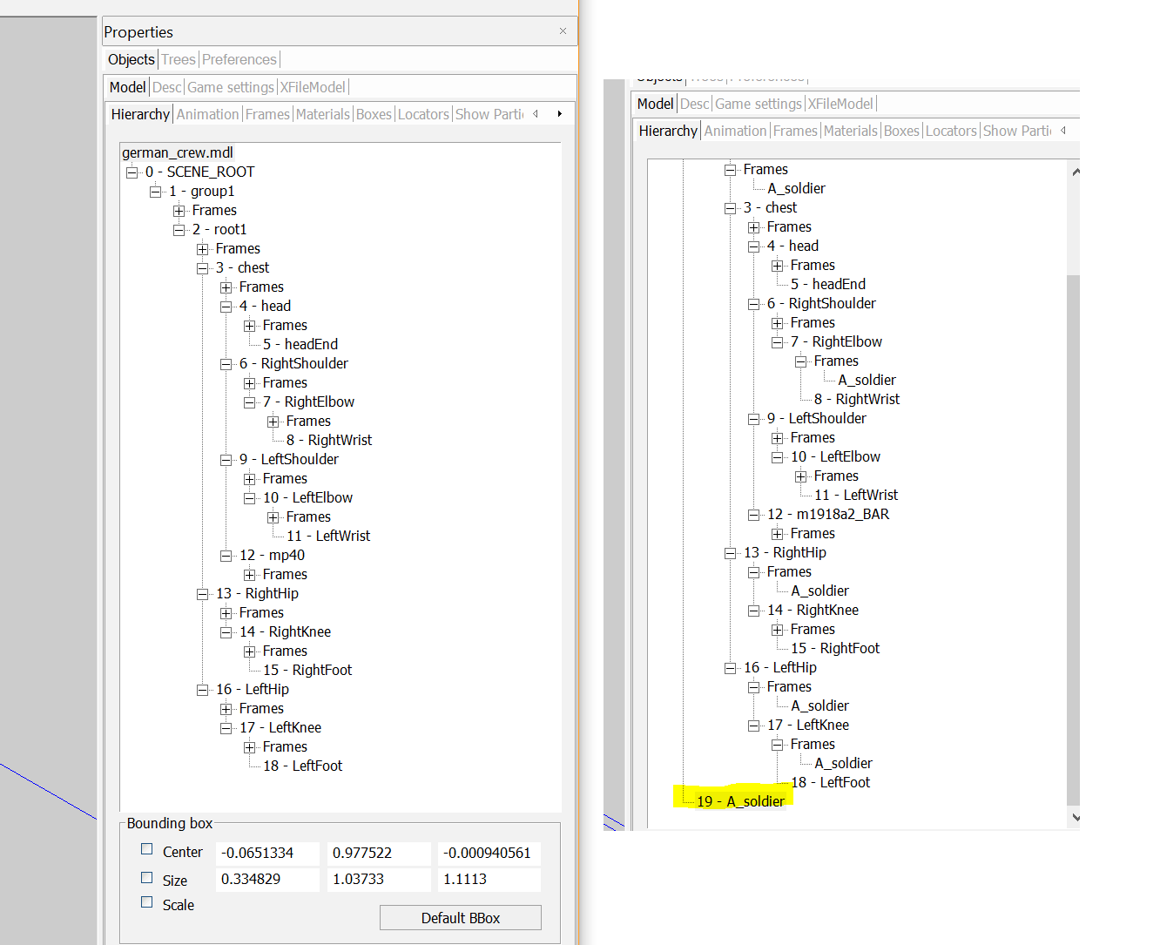
Note that this artifact could indicate the model can be deleted as everything carries across as an animation (bones that possess a name and vertex groups that all possess the same name as the mode, explaining the recurrence of the defunct name?)

Interpretation of the hierarchy as a body
The way everything originates from a central point (the root1 frame) like a spider’s limbs, when interpreting the hierarchy, indicates the connection of bones. The root1 frame parents the hips and the chest, which in turn are hubs parenting other parts.
Note that “bones” comprise their own length rather than the point at their end, which is the key thing, and the end point is really the key thing that is going to be used. The length just denotes the connection to the point it elongates from
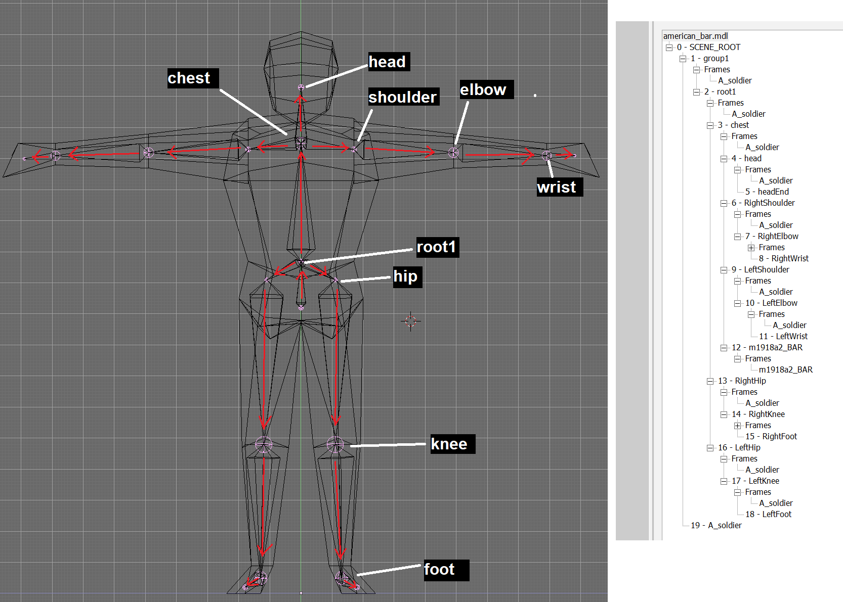

Possible explanations of “headend”
It may be that the developers added an extra bone (like an invisible pin emerging from the soldier’s head) to allow more head movements in the animation, especially when the soldier dies. This should be applied during animation tests.
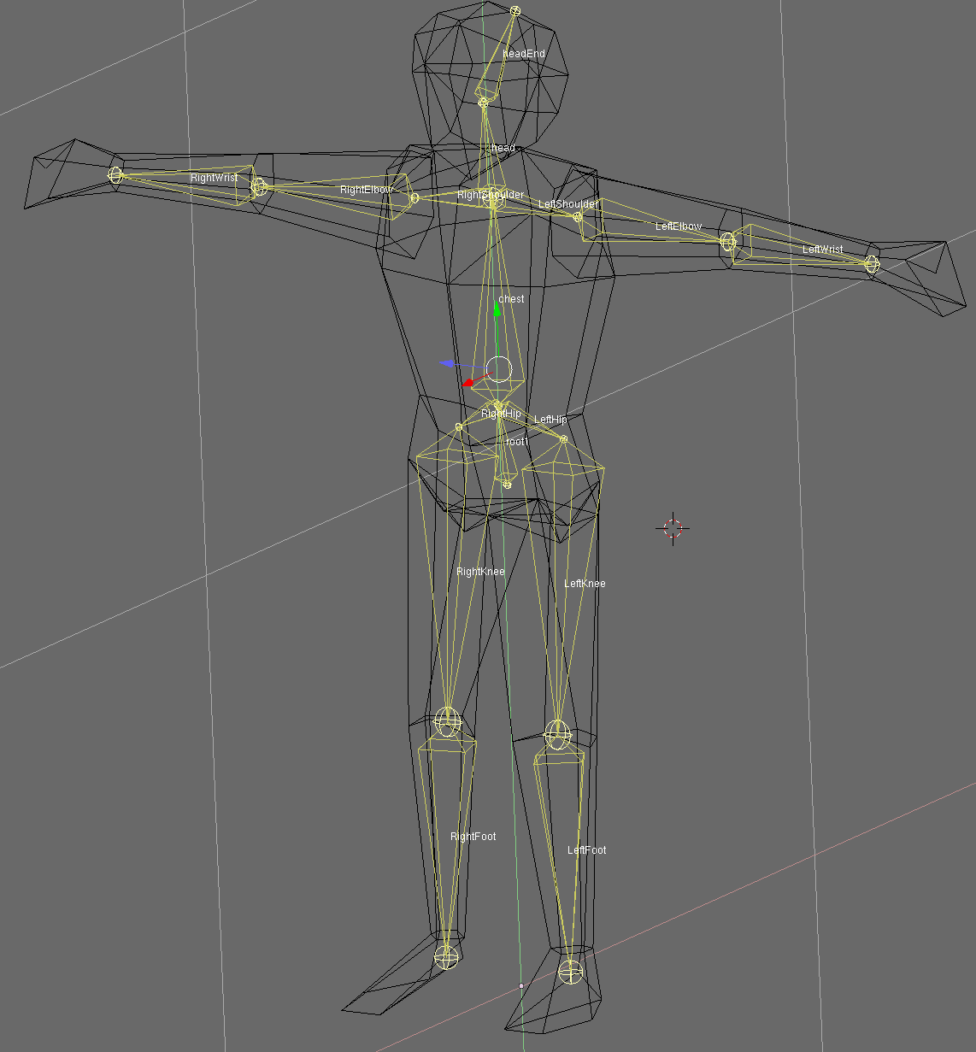
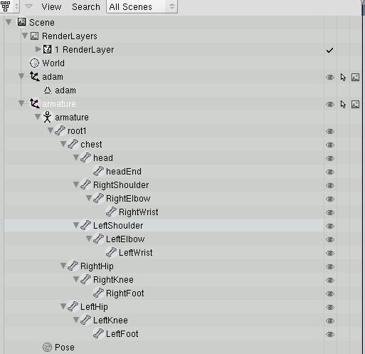

Test results

Intermediate test: Gus
The gingerbread man with bones in it but no animations, failed to appear as a model in the Object Editor. The nature of this error is not known
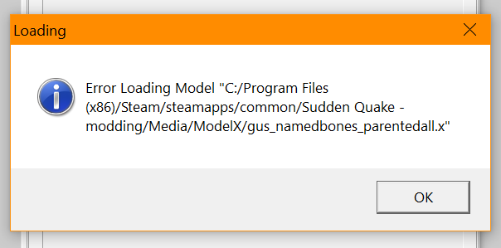

Tests based on following the manual
Failed to export properly. Model broken. From modding log:
*Adam - unable to export the animations, model breaks
* when his anims are removed, the directx file then is broken on export when opened in OE
*Eve - unable to export the animations, model breaks
*when her anims are removed, nothing appears in the OE and then it crashes when making model
*requested help and gave a breakdown of the issues and errors via Discord

Possible remedy – export settings
Copied from source: https://www.ambiera.com/forum.php?t=5304
Export to .X with animation for CopperCube
===========================================
1. Rig and animate model
2. Select Armature and then shift + select the mesh which should be the child of the armature
3. File->Export->DirectX
4. Here are the settings for export. This will drive you nuts if you don't know them:

Export Selected Objects Only: CHECK
Coordinat System: left-handed
Up Axis: Y

Export Meshes: CHECK
Export Normals: CHECK
Flip Normals: NO
Export UV Coordinates: CHECK
Export Materials: CHECK
Reference Active Images: NO
Export Vertex Colors: CHECK
Export Skin Weights: CHECK
Apply Modifiers: NO
Export Armature Bones :CHECK
Export Rest Position: NO
Export Animations: CHECK
Include Framerate: CHECK
Export Actions as AnimationSets: NO
Attach Unused Actions to First Armature: NO
Verbose: CHECK

Result
Attempting to do the above, I just don’t see these options and then the result in the Object Editor is a failure to load (see the “error loading model” error above)

Video tutorial clues
https://www.youtube.com/watch?v=ujd2l9wVAsU&ab_channel=RobinFlodin
*do not use spaces or other types of extra punctuation in naming anims
*have a start and end key in animation
- not able to learn anything new or relevant to the issue

Remedy with Blender 2.62
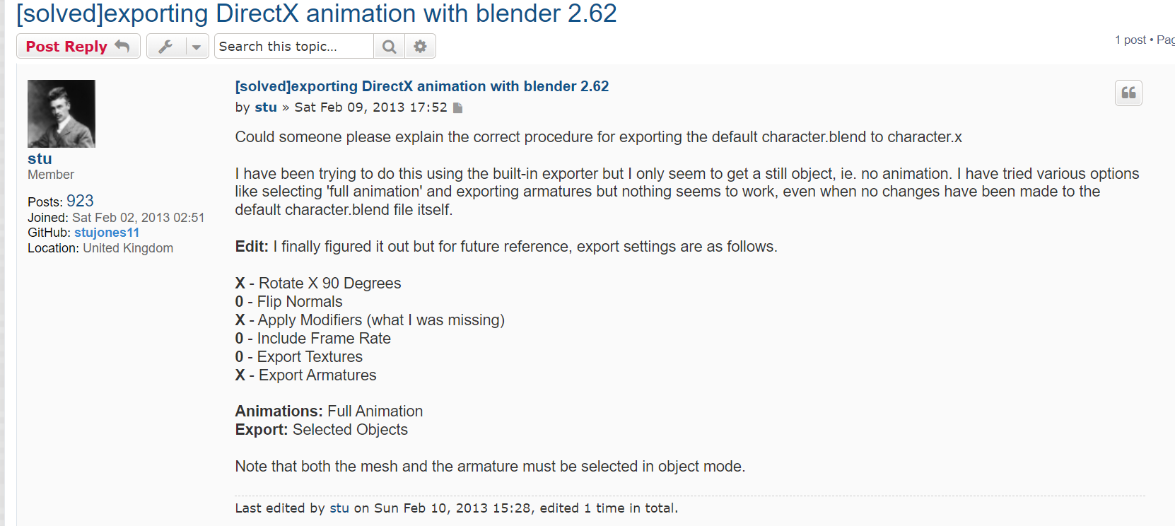

Possible remedy with scenes
If the different animations are stored via skeletons in scenes, and the original object has no skeleton in it (seemed to be implied in the bits of advice in Discord), then it may be that creating the animated character, copying whole to another scene, and then removing the bones from the original, will work. Note that the initial characters as they appear in the Object Editor are actually in their neutral pose, indicating there is no pose, whereas mine start in their idle pose because I only created poses via the actions editor.

Result
Did not work. In this case, the character imported to the Object Editor correctly but possessed no hierarchy consistent with the original game models. This suggests I was closer to being on the right track earlier, rather than now.

Possible remedies – tests with Blender 2.79
Followed instructions at https://forum.omnibussimulator.de/forum/index.php?thread/45148-way-s-to-import-to-export-x-file-in-bledner-2-7/
See the download “spamandeggs-directX_blender-b928e0a”
This is to make Blender 2.79 capable of exporting directx

Additional options used, 2.79 version used
I opened my blend, Adam (temporarily saved in My Documents), and exported to directx with several settings applied fairly randomly
Additional options are present there (not the configuration used in this test but this is how it was)
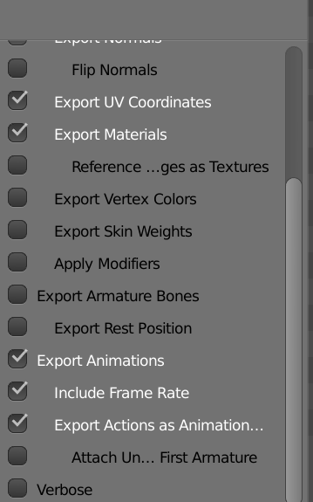

Result
Result is that it did not export successfully; the model is not broken, but the hierarchy is absent, animations don’t load and he is still upside down. Could carry out further tests in this version
Slight improvements
See adam_anim_attempts_idle_and_running_279.x as the file resulting from the above attempt
Positives
“AnimationSet” is created in this Directx file’s text, unlike before, and is named (there is no running animation)
The idle position is assumed by the model in the Object Editor
The model is not broken or distorted even after model generation in the Object Editor
Negatives
No hierarchy of vertex groups appears in the Object Editor
No animations appear in the animation tab; they did not get picked up in the Object Editor
This setting seemed quite close to success but still got the model upside down and failed to bring in the animations
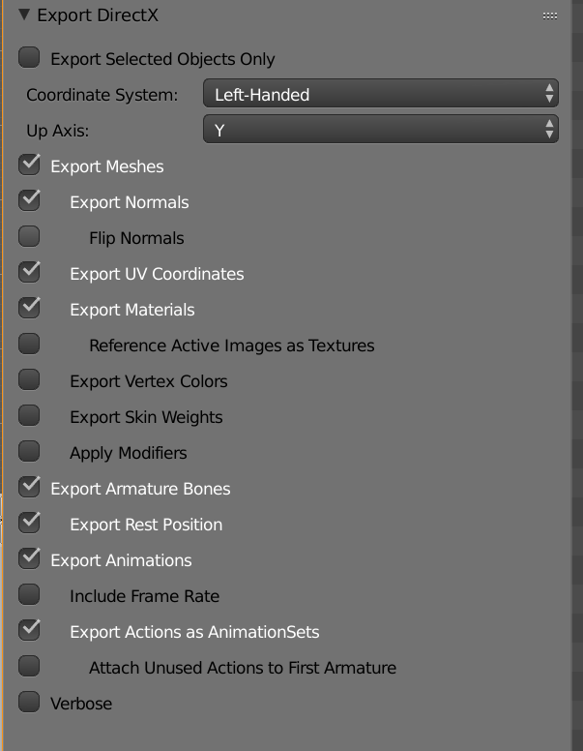
Best prognosis is to acquire one functional directx file, so as to compare the products created by 2.49 and 2.79 with that file and conform to it

Possible remedies – Fragmotion and fbx exports
See this comment:
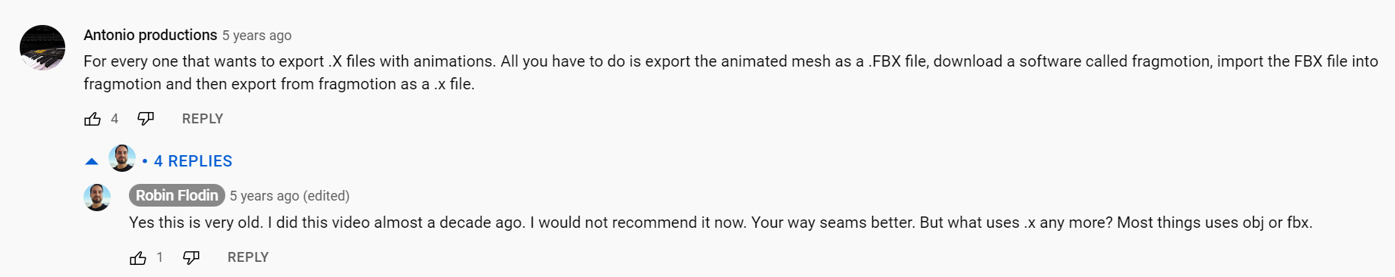
Fragmotion can be downloaded at http://www.fragmosoft.com/downloads/index.php, see the resulting folder “fragmotion_137”

Result
Doesn’t seem to work. On the free version, fbx is not a supported file for import. Importing the directx file and then re-exporting results in a dead file that still doesn’t work for the Object Editor

Getting anims into Object Editor, with OE’s Animation tab
Rather than appearing right away, the animations (held as actions in Blender) seem to appear this way:
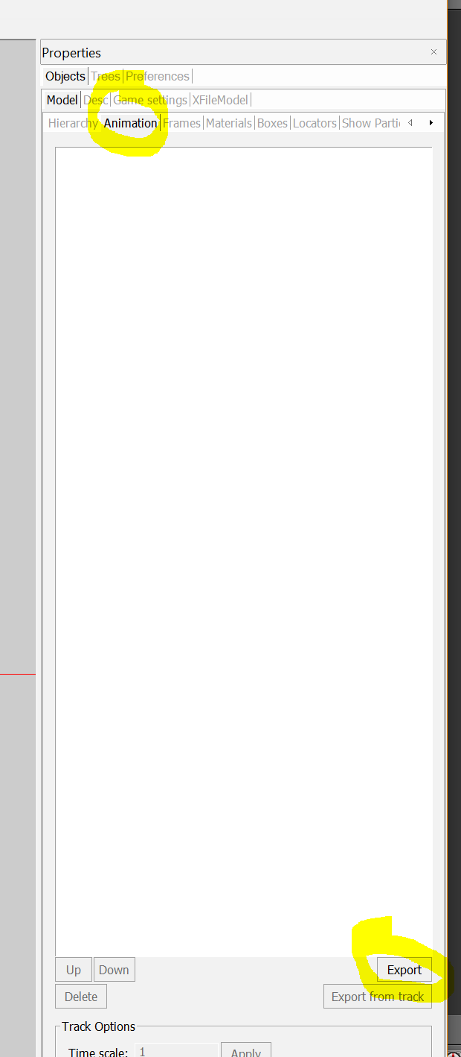
After going to “Animation” and then “Export”, we get the “Export Track Animation” screen. It has a drop-down menu of options
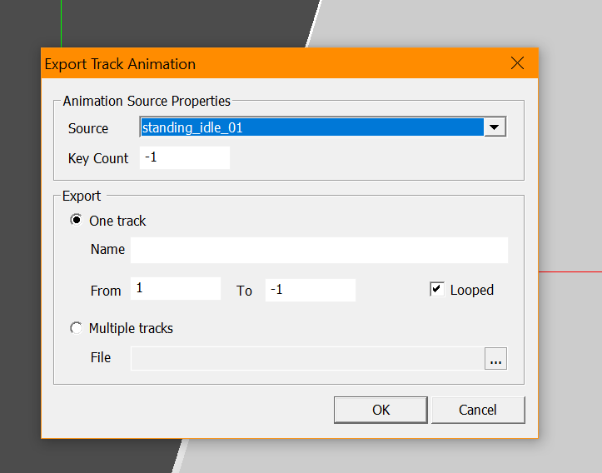
What we may then do is fill this in, like so:
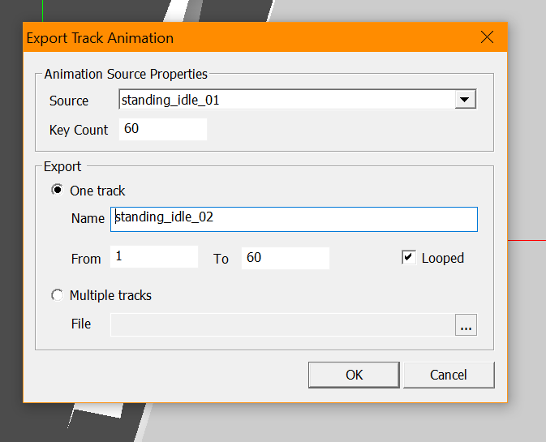
Select OK
Then, you can have animations that work

Result
Regrettably, the above is now only accomplished with the model being destroyed in the process now, so something is still wrong. The above result was achieved by exporting the directx file from Blender 2.79 with the below settings applied:
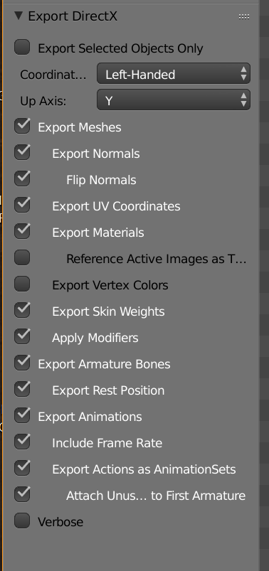
Note, this was done with the file C:\Users\hjben\Documents\adam_anim_attempts_idle_and_running_animnames.blend
It produced the file adam_anim_attempts_idle_and_running_animnames_d.x
The next goal should be to get the model oriented correctly and prevent its destruction, to that end, settings could be toggled and the soldier could be moved the other way up, with all results being noted thereafter

“Simpleman” a test case, soldier oriented normally when editing
Tested according to the same export options as the above

Result
Failed, object was distorted and the Object Editor application crashed when trying to export the animations. Could not see orientation because nothing actually loaded up initially at all

Troubleshooting the “Getting anims into the Object Editor” success

Remove “export armature bones”
No hierarchy
Error generating the model

No normals exported
Error generating the model

Coordinate system changed to right-handed
Error generating the model

Revisiting the close success for ideas
Searching the locations of parts of the hierarchy, it seems the problem could be that the armature’s size is disproportionately large relative to the vertices. Consequently, the mesh stretches to adhere to the faulty locations of the armature? On the other hand, there seems to be no coherent pattern to the armature at all
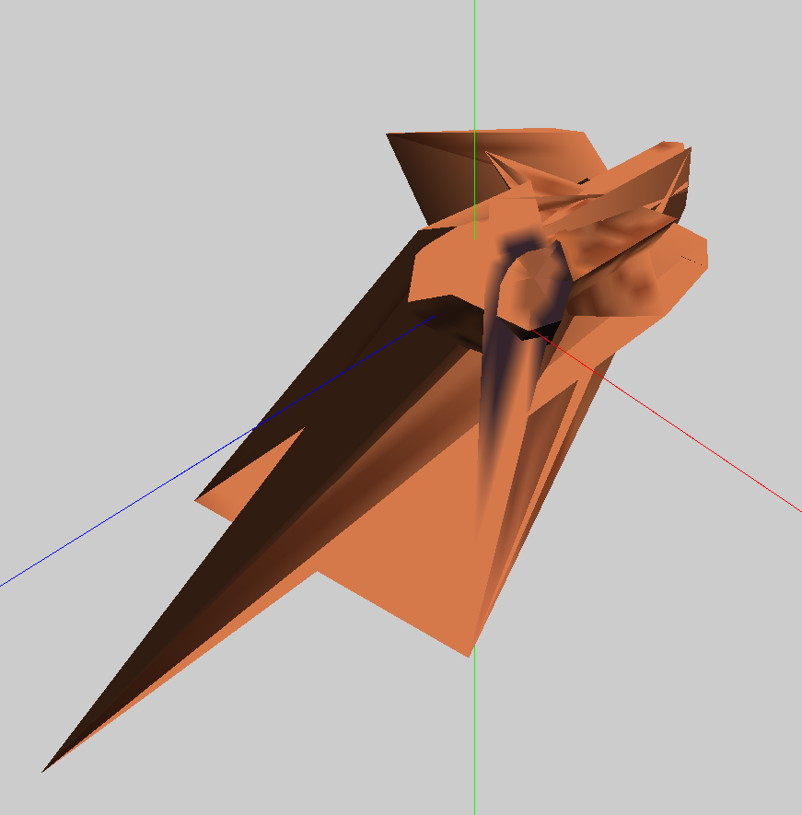
Above: adam_anim_attempts_idle_and_running_animnames_d.x in close study
This suggests the issue could originate in the Blender model itself
Note that in earlier errors, we had broken models of buildings, tanks and even a crate (a simple box) that somehow failed in the Object Editor. In those cases, the answer was just to keep making a newer model with better technique, simpler, in Blender, until it worked. In the case of infantry, making a stable rigged model may mean a model that can be adapted and complexity added to make further infantry

Adjusting the pivot point?
If we look at https://www.youtube.com/watch?v=ujd2l9wVAsU&ab_channel=RobinFlodin, it describes a grotesque distortion arising from the “pivot point” of the armature and the model being misaligned; it also warns that getting the pivot point correct should precede the creation of the bones

Result
No effect, still destroyed model

Remaking the armature?
It may be that the order undertaken to make the armature was wrong if it went like so –
(1) create armature in Object Mode (2) position armature origin in Object Mode (3) scale armature in Object Mode (4) add and scale bones in Edit Mode
Since the Object Editor won’t accept the positioning of vertices in Object Mode according to previous errors, it may struggle with the scaling (and hence movement of an end point or tip of a bone) in Object Mode at any point, which can result in this distortion (if the armature is resized in ways the Object Editor won’t accept, won’t all the bones then be getting created according to the incorrect scaling in the Object Editor when the object renders?
Then, the correct order should go like so –
(1) create armature in Object Mode (2) position armature in Object Mode (3) scale armature in Object Mode (4) add and scale bones in Edit Mode
Therefore, the skeletons may need to be remade primarily in the Edit Mode
Result: makes no difference, models still broken

Remaking everything until something works?
Another possibility is some sort of corruption of the mesh similar to that faced with objects and vehicles in earlier efforts, with the remedy just being to make everything once again
Result: broken, animation not working

Quicker solutions?
Since the above could take a lot of time and have no guarantee of success, it may be best to explore some other options first, such as applying different settings, if any exist in Blender, to the skeleton
Result: nothing seems to work

Comparing a Blender issue to OE issue
If we look in Blender, if we move the character, for some reason only the arms try to adhere to the skeleton
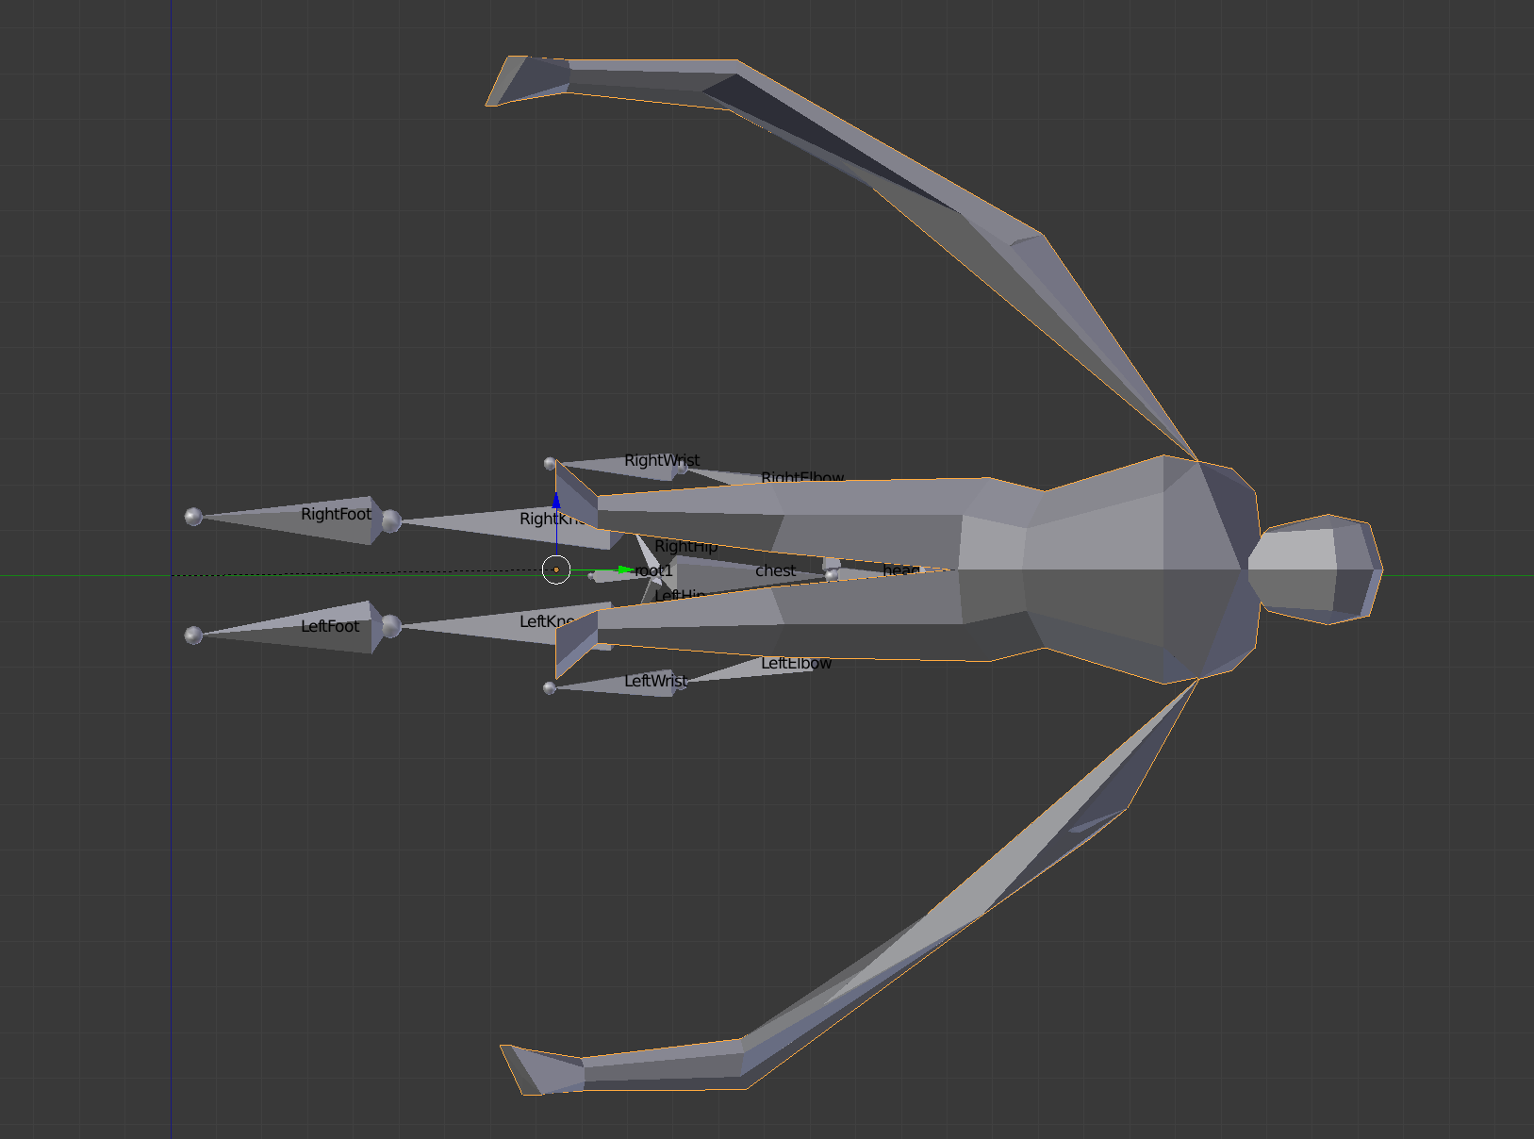
The result distorts a lot more in the OE, like this
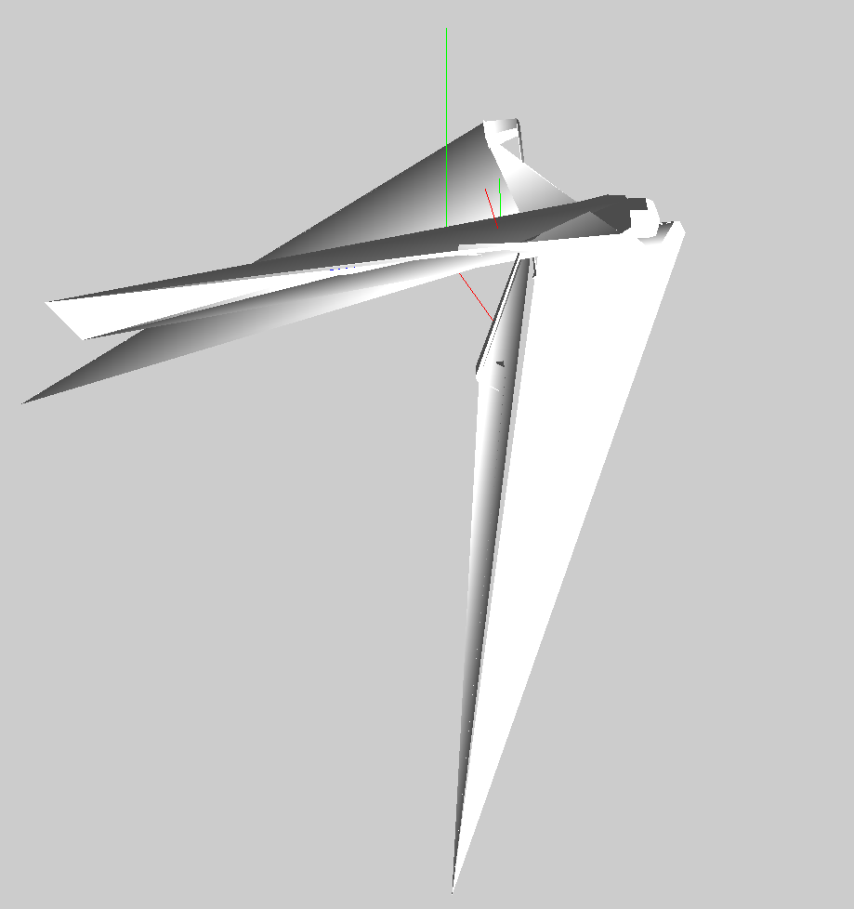
Also note: attempts at this with the “Eve” model using exactly the same process met the same fate as the “Adam” one but worse, indicating it could very well represent flaws with the model; attempts with “Simpleman” also were complete failures as well, though, indicating the problem could be anywhere still

Dragging “root” bone to origin

Result
Failed in every way, broken and the animation doesn’t work, even following the precise steps identified above for that purpose

Solution for now
The best conclusion is that the construction of the character was flawed. Build a new simple character or animate again an existing character using the Blender manual sections, but in 2.79, and follow every step as per the above success routes to see if there is a better result
Result: failed

Preliminary result
An attempt to simplify the existing model failed but it somewhat improved the model, albeit that this version had only three bones in it and this may explain its better result; it appears to be the right way up and parts seem to be intact
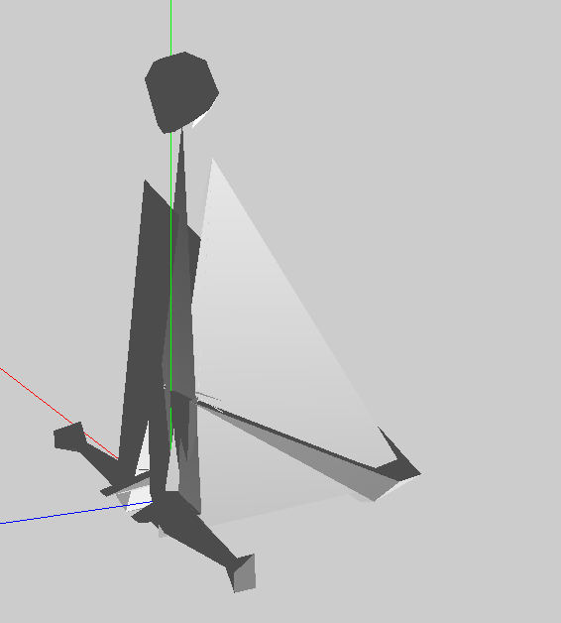
When the bones are reduced, there is basically no difference.
When the armature is gone entirely, the body appears the right way up but there is no way to get the animations to work.
Whether bones are removed or reduced in the above version, there is an error when trying to configure the animation.
The best conclusion is that experiments should go on, with ever simpler shapes

Cube built in Blender 2.79
The shape is not distorted, it has an animation in which it rotates, but the Object Editor cannot generate a result (it crashes)

“Simpleguy”
Simpleguy’s bones are not parented to each other, they just rotate the vertices, and “LocRot” is not used to define the keyframes, only “Rot” is used
The “errordumped” message is now becoming very frequent in these tests of simpler models, and could be due to the Object Editor not finding what it expects for infantry

Returning to complexity
If the Object Editor requires the complexity of the existing infantry, that complexity needs to be better understood. Here is a comparison of the hierarchy between my closest success and the closest success of the original:
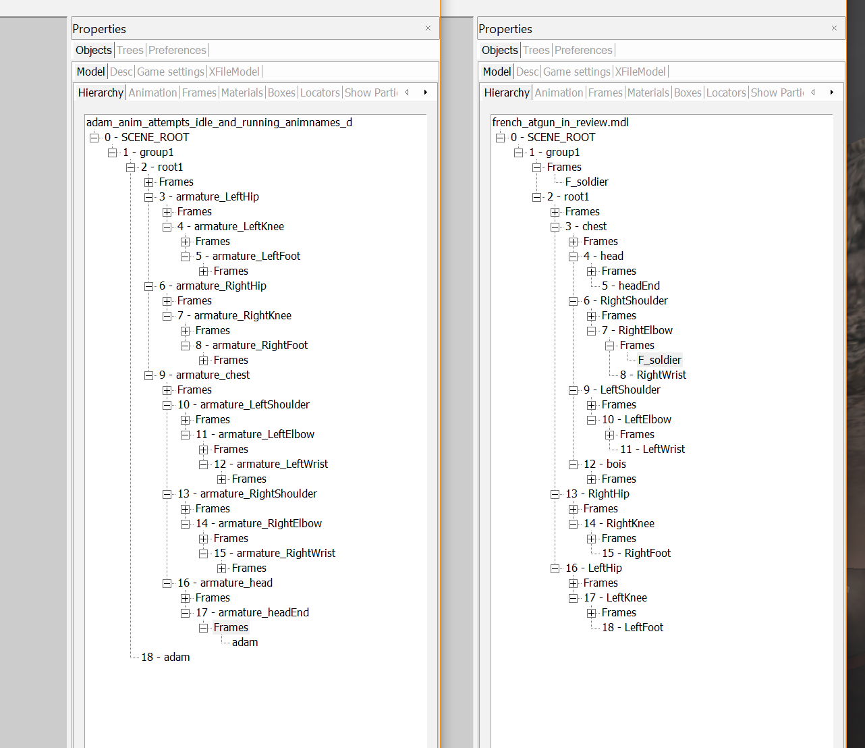
Note that “group1” has an origin at the feet of the soldier which is either the point of origin (hence the top item) of the armature overall, or of the “group”
Study of a disassembled French AT unit reveals that every part of the AT unit, even the shoulder, has vertices in the game. The only part that does not, is “group1”. Even the hip has vertices and they, when displayed without other vertex groups, point always at the point of origin, presumably belonging to the armature:
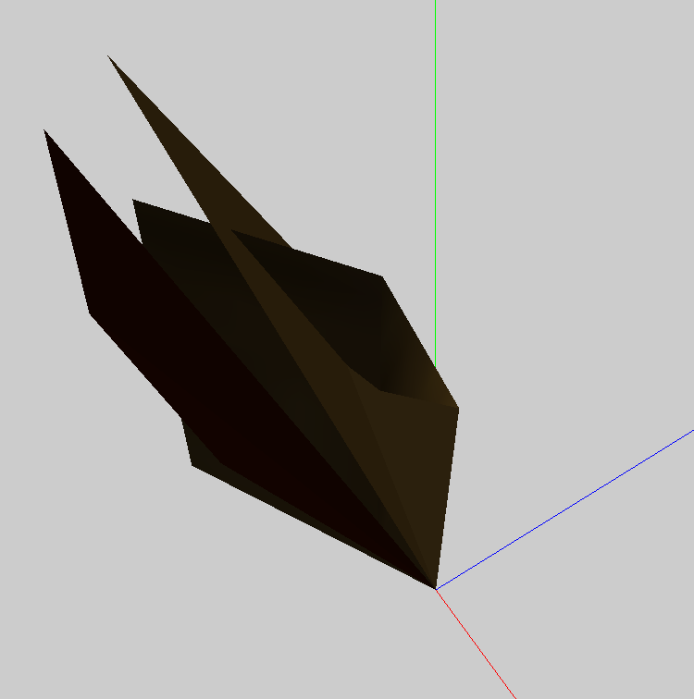

Testing the distortion effect
Testing the distortions of male_body_simplified_rigging_reattempt (left) and male_body_simplified_rigging_reorient (right):
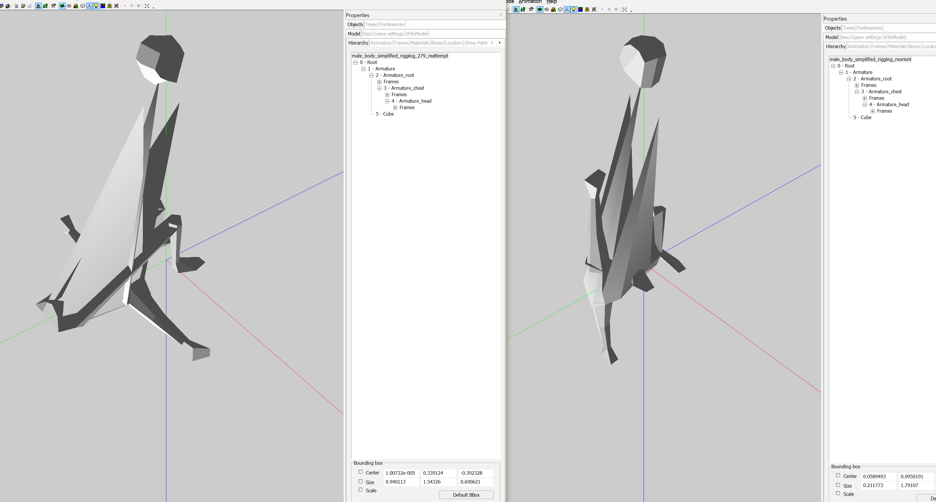
In this case, something is forcing the body down
When looking at the original models, the “root” frame has a location in the centre, maybe at the point where all limbs or appendages converge. In mine, the location shows as the bottom of the model:
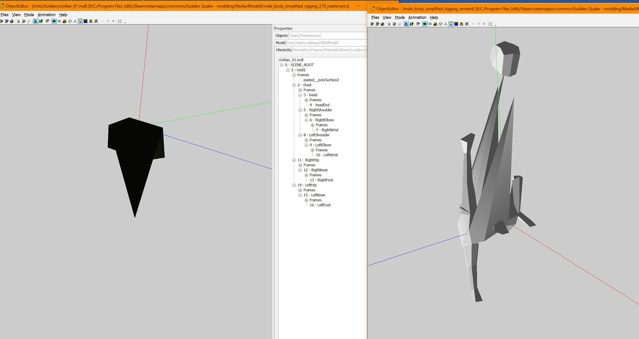
The model, having been reoriented, should be simplified further. The armature’s location should be brought up (the scene root location isn’t the same, that stays at the bottom, whereas the root of the armature perhaps belongs somewhere in the middle). Also, the bones should be remade in their full complexity as with the successful attempt already recorded, and should follow the process (LocRot) as used at that time. There is a possibility that the root bone was rotated in object mode, hence the terrible behaviour of everything in the root in the above examples.

Thesis of the separation of vertex groups (is correct!)
Judging from the original characters in the game, it seems that their groupings of vertices never overlap. Look at the progression as follows.
Chest:
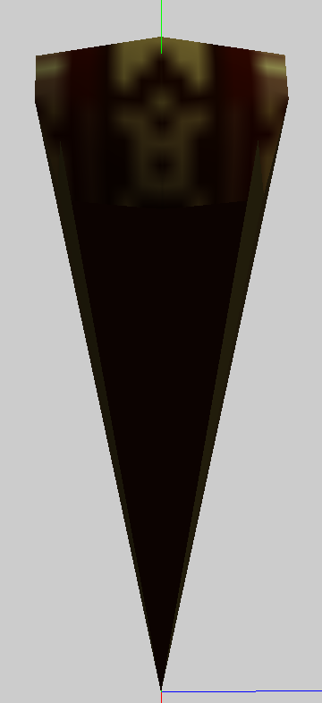
Shoulder:
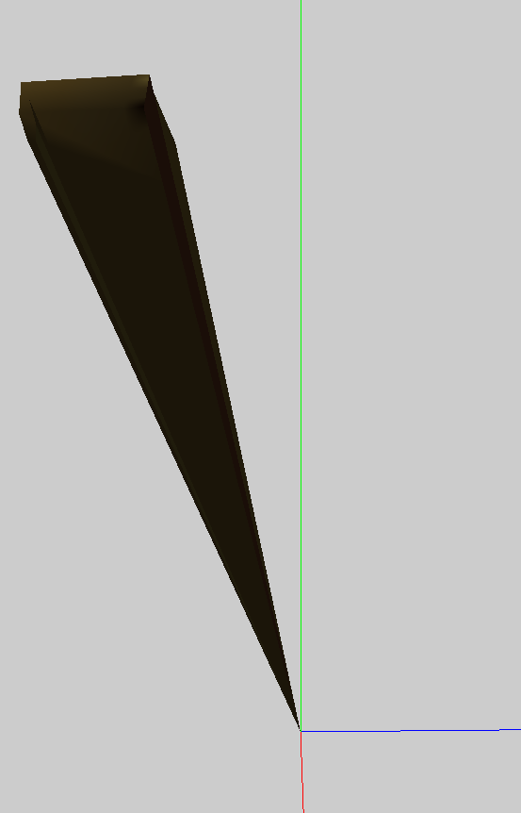
Chest and shoulder:
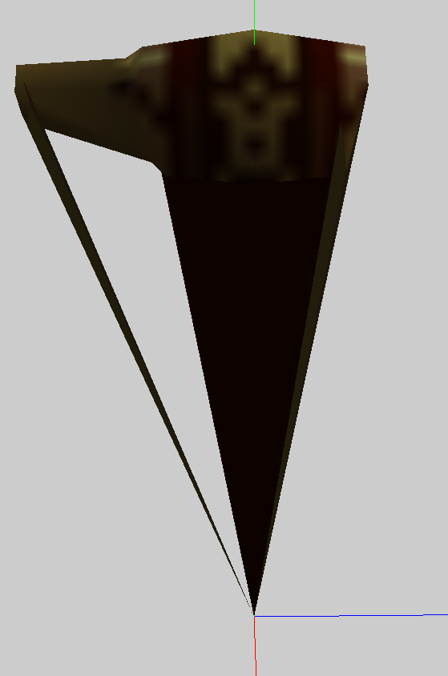
Here, we see that faces are missing entirely when the individual parts of the body are separated. Every part of the body (vertex group and possibly corresponding bone) contains its own vertices in the original game that are not shared by other parts.
In the case of the “root” part, this appears to reduce solely to the set of vertices with no faces at all, although the game colours this one-dimensional shape in by warping it to the origin point
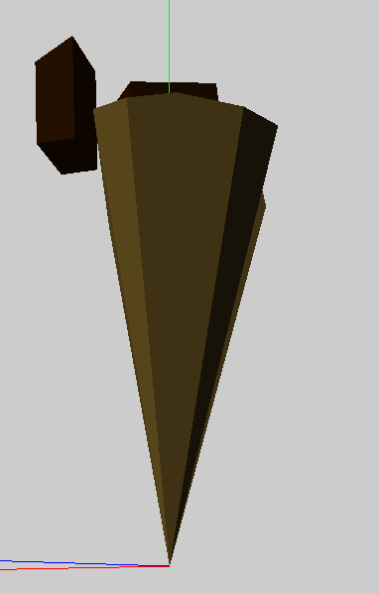
The question of why everything warps to the origin point when other frames are not shown is not clearly understood, but it happens in the test version that achieved animation, albeit with everything distorted and broken:
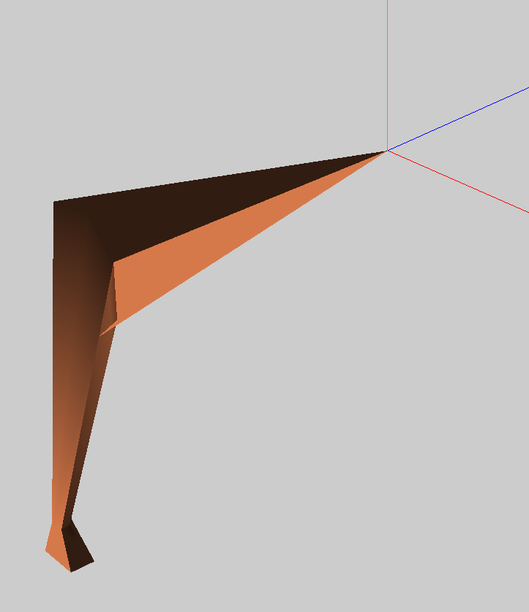
In the simplified rigging attempt, we see a very specific pattern of results from the way the vertices are grouped:
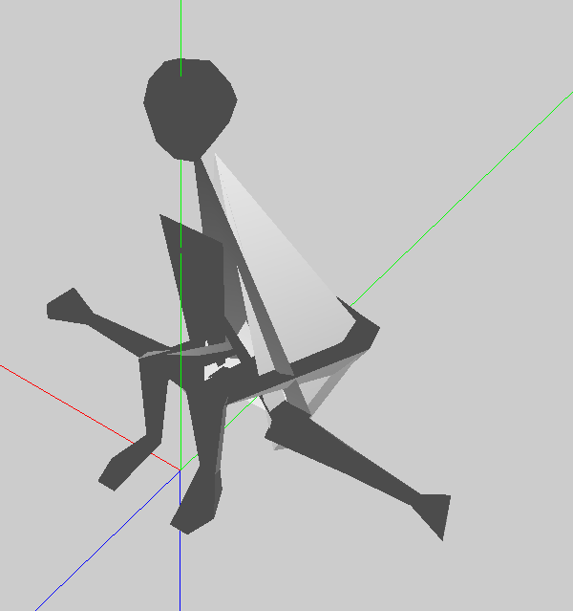
The head and feet are in the right position, the arms are intact, but other parts are distorted.
Parts of the body may be shared in the area of distortion:
Root
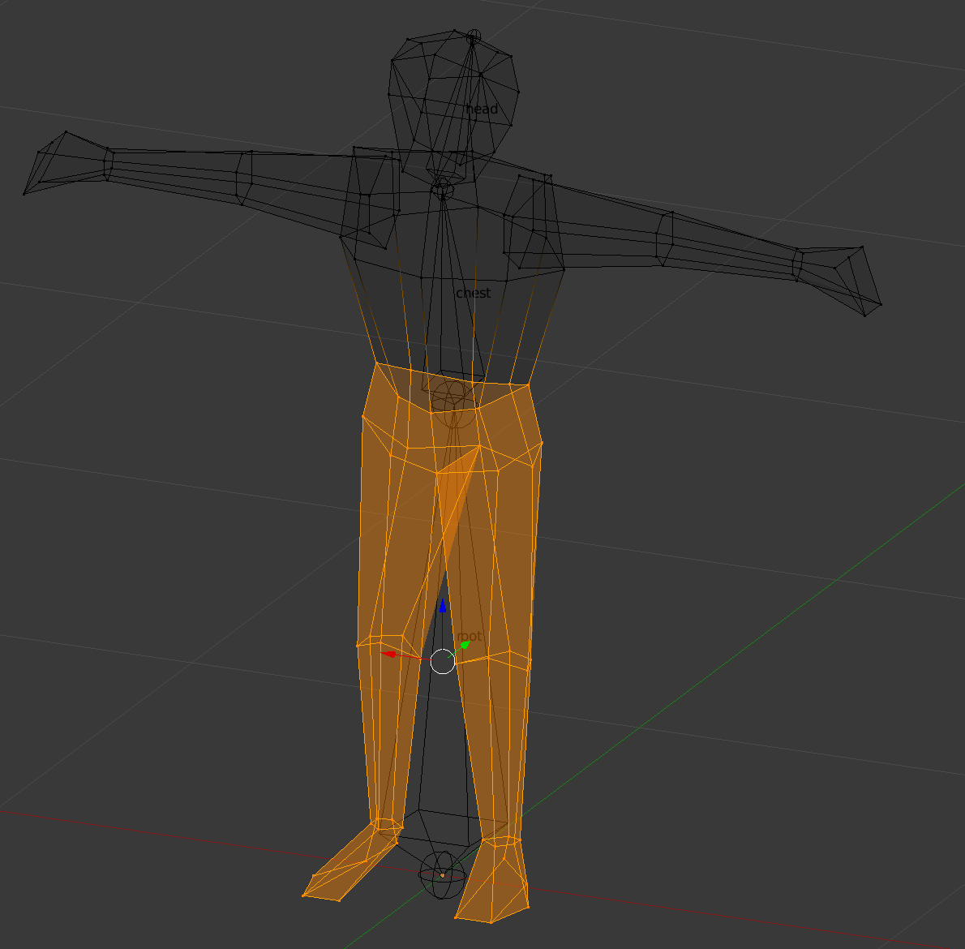
chest
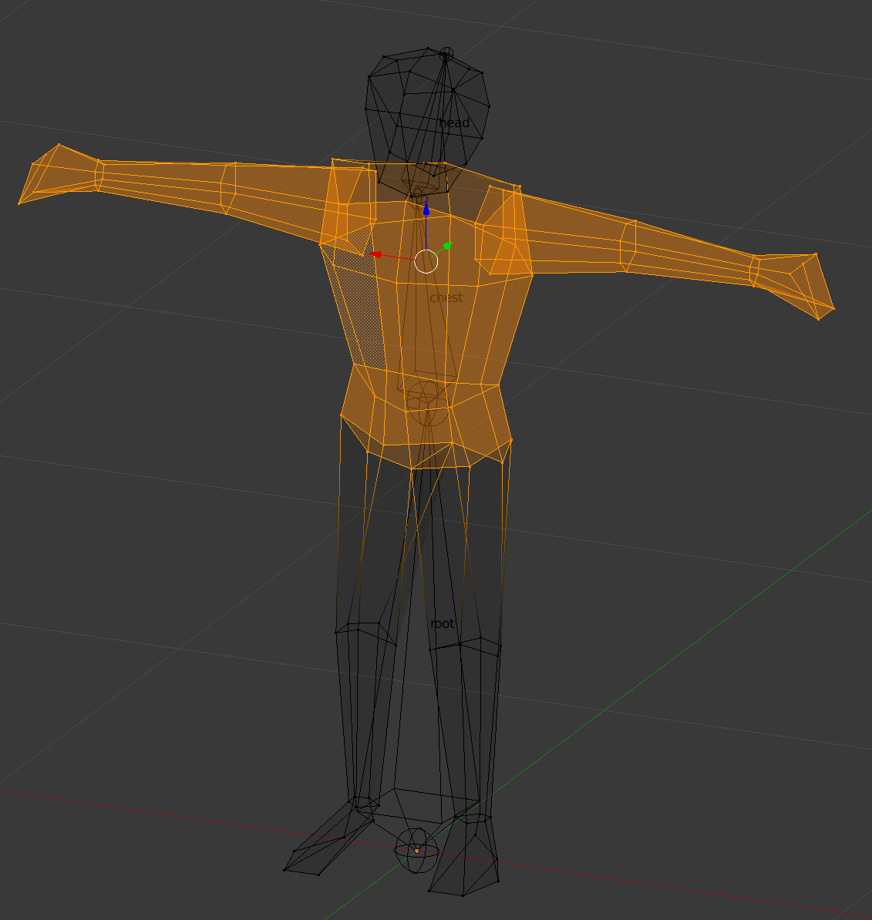
head
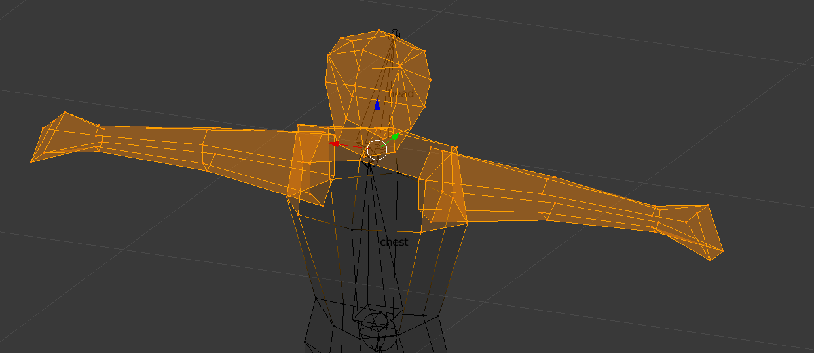
This thesis could explain the pattern of destruction seen (the legs and head have vertices that belong solely to one group or bone, but the waist, arms and other major parts do not; this could mean that the OE just sees conflicting data or something it cannot understand when a vertex is shared between more than one group)
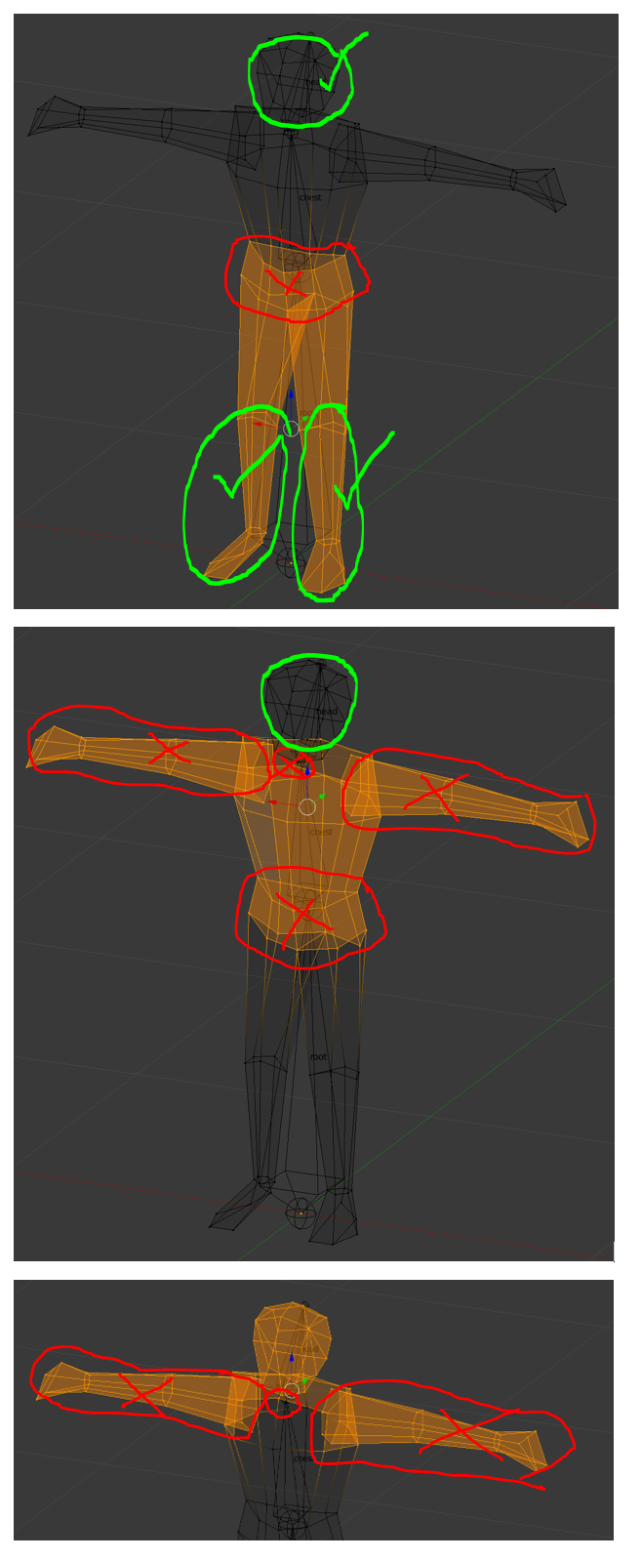
If this thesis is right, each bone should possess its own vertex group (having a distinct gap between each such group where the faces would be incomplete if the other part was deleted, but which is bridged when the pieces are present together)
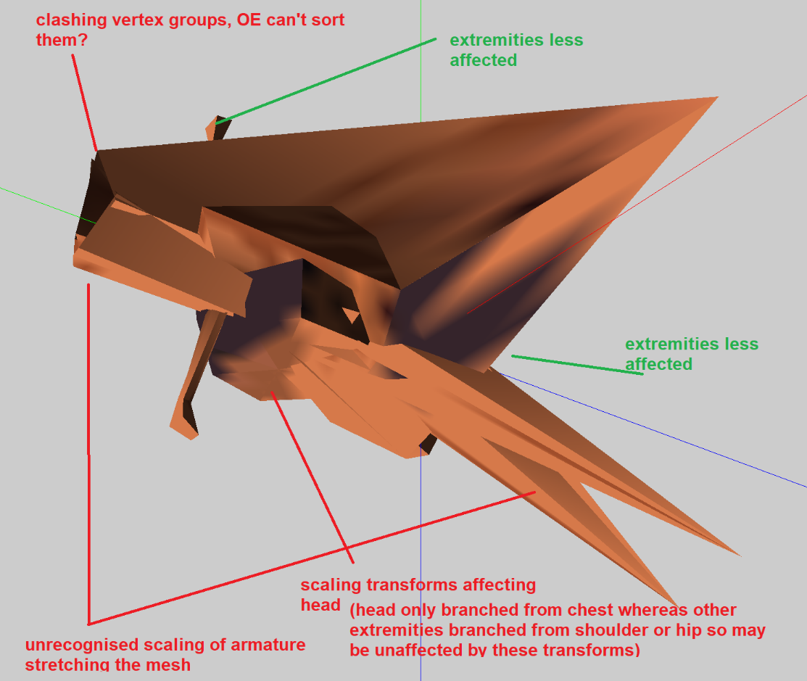
Extremities (hands and feet) are consistently less affected, likely as they are much more independent than the other sections (more likely to be part of a stable stretch of bone not affected by issues with the root, and also less likely to clash with other vertex groups), strongly supporting this conclusion
An attempt to understand the original issues with adam_anim_attempts_idle_and_running_animnames_d.x, in which animation succeeded but a strange disruption effect held back the result

Construction method revised based on the vertex clash and bone scale thesis (not effective; Blender 2.79 is broken for this purpose, see Blender 2.49 as the solution)
- Orient the body correctly (see male_body_simplified_rigging_reorient) viewed from the front, he should face rightwards on the x axis. His object origin point should be 0,0,0
- Separate the body into vertex groups: root (just a belt of vertices); chest (parts above there, excluding the points that will be shoulders); shoulder right, shoulder left, elbow right, elbow left, wrist right, wrist left, hip right, hip left, knee right, knee left, foot right, foot left, in conformity with the vertices used by infantry in the existing game
- Place the 3D cursor at the centre (0,0,0) and create the armature there. This is important because any subsequent changes to the armature can only be made in edit mode, but the origin point must be correct in the first place for it to work. Any rotation, movement or scaling of this armature in Object Mode will be highly disruptive to the end result as the Object Editor will not recognise it when generating the model and will reverse all the changes that were made in Object Mode
- In Edit Mode, move the first bone of the armature (this is to be root or root1), to the position of the waist vertices of the root or root1 vertex group
- Still in Edit Mode, use ctrl and left click to place bones originating from the root bone’s tip based on which bone will be subservient to it. Do the same with each subsequent bone (the chest and head follow, with the latter subservient to the former)
- When the skeleton is complete, parent each bone (ctrl+p) to a distinct vertex group, ensuring that every bone is the parent of its own set of vertices that are not shared by any other bone
- Create animations in pose mode, ensuring to save their positions at each keyframe according to the (after pressing I) “LocRot” option
- In Blender 2.79, use the export options indicated in “Getting anims into the Object Editor” as repeated in figure a
  - (DOES NOT WORK)

Result
While there is no disruption to the model structure anymore, attempts to animate the result in the “error dumped” message now, once again trapping the process between destroyed models and animation errors

Analysis of discrepancies
The sole major discrepancy apparent between the latest failed model and the original models in the game is that in the original game, there may also be faces associated with each bone rather than only vertices
Taking a look at the directx files, they are just too long to study their text, compared to those with models. This means tests will be limited to visual discrepancies
The good thing is that the two major issues obviously have a route that solves them; one is solved with export options in Blender 2.79, the other is solved by constructing a certain way, but it is proving extremely difficult to balance the two without making some other mistake that is hard to perceive

Further test – falsifying the theory
Does creating from bone heat rather than manually setting the vertex groups result in destruction, as expected?
(see file “male_body_simplified_thesis_step_d.blend” for the test file)
Also, does the resulting file work on directx export?

Result
First, the theory about the vertex groups clashing is correct, this is causing the destruction
Second, the theory that creating from bone heat results in the animations working is false – the resulting animations do not work but instead the error happens
The issue now is the recreation of the effort that led to successful animations in the file adam_anim_attempts_idle_and_running_animnames_d.x
How could this happen?
It is created from the file C:\Users\hjben\Documents\adam_anim_attempts_idle_and_running_animnames.blend

Solving broken animations with Blender export
When exported from Blender 2.49, now, male_body_simplified_thesis_step_d.blend (now adapted as male_body_simplified_thesis_step_e.blend, has a shattered model but a working animation
Settings used were:
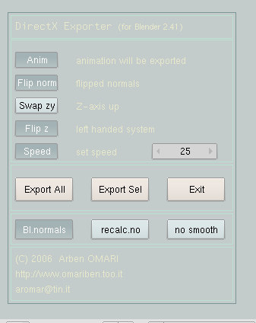
I also made that not just standing_idle_01 and standing_idle_02 were present but running_idle_01 and running_idle_02 were present in the animation actions, not that this may be necessary
Reverted to step C to test if the version not created from bone heat functions, see the result male_body_simplified_thesis_step_c_e.x
The above test successfully incorporates the object and its animation
The only remaining issue now is that all the animations are now stored as a single “set” rather than separate ones (the actions did not recognise as different “sets”)
See male_body_simplified_thesis_step_c_success.blend as the successful test
Created male_body_simplified_thesis_step_c_twoanims.x to see if specifying a “track” in the Object Editor can pull the animation out of the single set
Unfortunately, it does not; the other animation is completely inaccessible
When multiple animations are all exported in a single track, the soldier is only able to play all of them at varied speeds and they cannot be isolated in the Object Editor (not quite correct – see later notes)

Editing the directx file directly to copy in the absent animation block
Trying to combine c_e (successful animation 1 handwave) and c_twoanims (successful animation 2 handwaves) by having “set0” and “set1” respectively in the directx file
The result, c_e plus, simply has two exact copies of the same animation accessible in it (see animation 2); when looked at, the actual content of the two directx files is exactly the same (as if they exported exactly the same animation, yet the Object Editor thinks it is two, unless they appear on the same file
Best to export some fresh animations to test further if they are all the same as this one

Freshly created anims to study Directx files
With male_body_simplified_thesis_step_c_animsplit.blend I am going to try two different options, a more neutral animation and one where the character bends a little and scratches his head
Result:
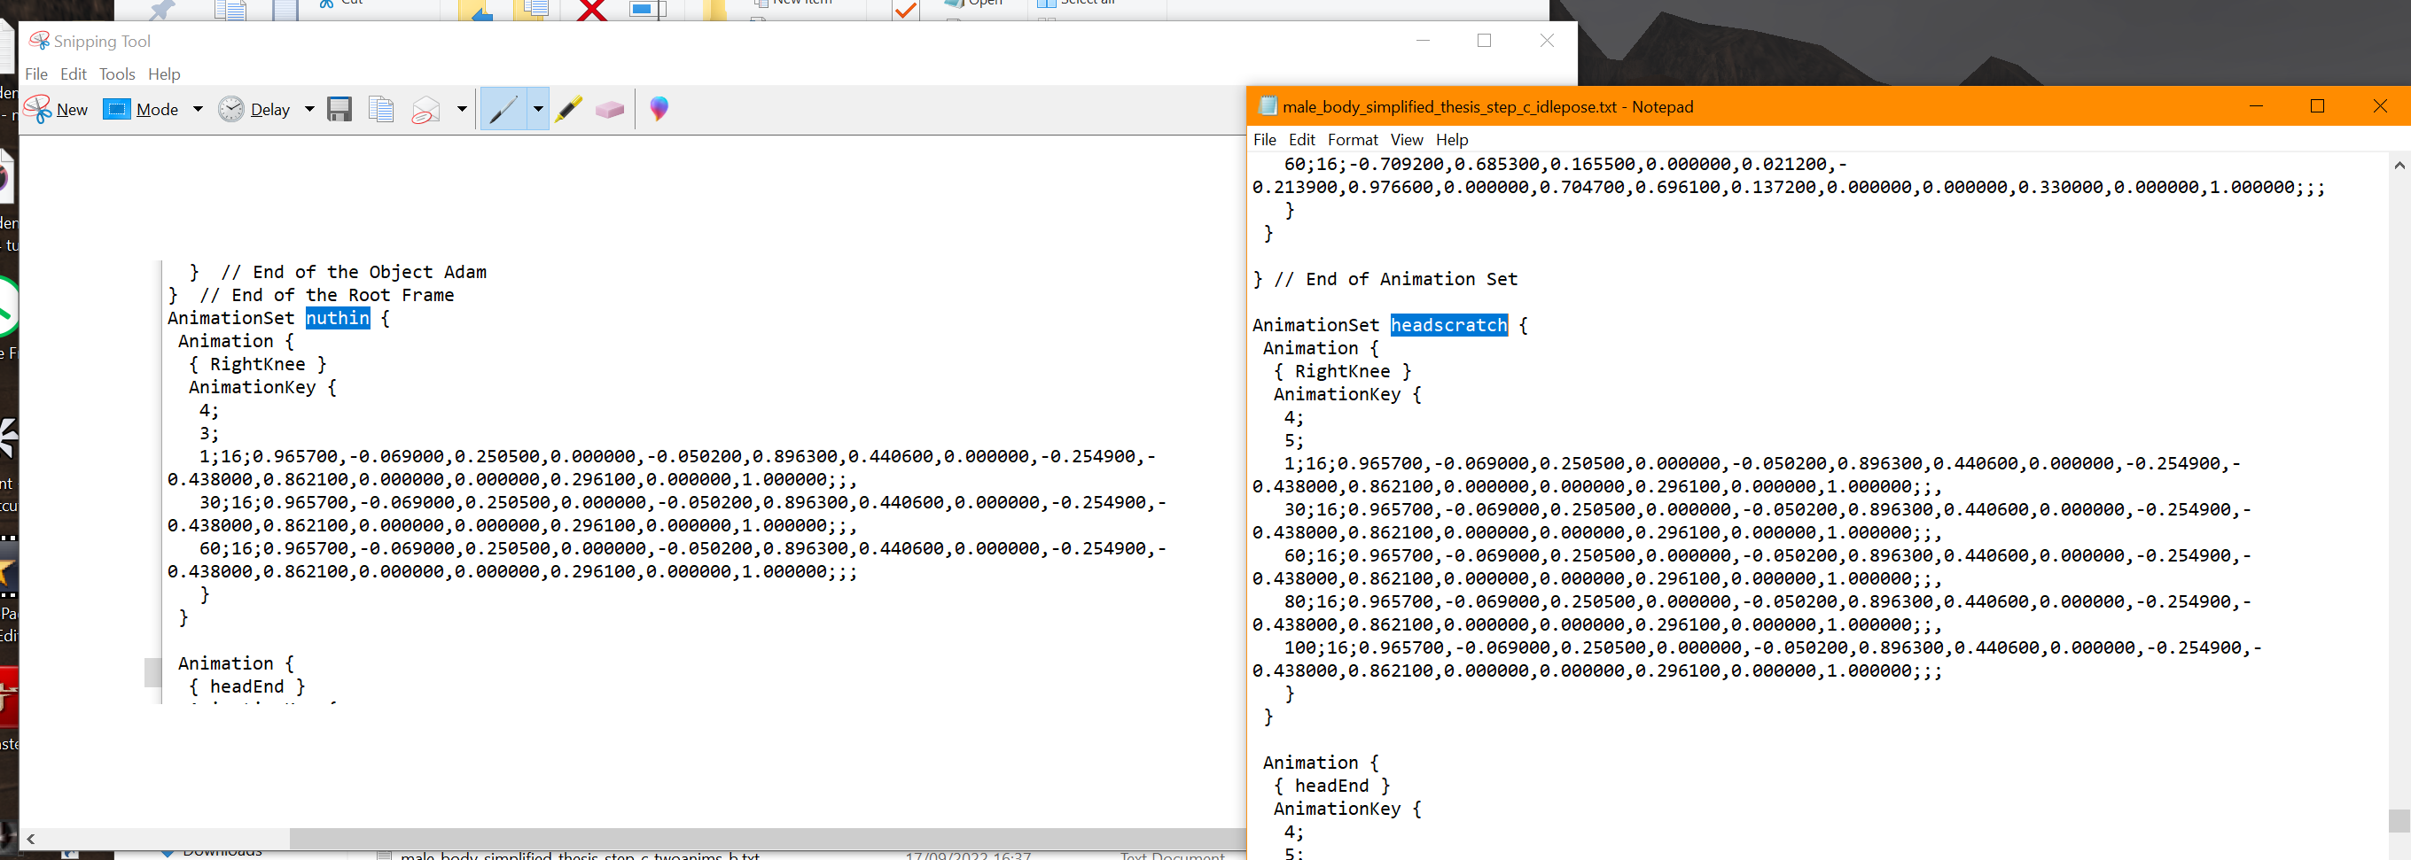
Tests result in failure: despite the animations being clearly different, they result in the same animation repeatedly, the Object Editor seemingly just thinks everything is the same animation, no matter how the directx file is written
Also, editing the closing part on there to close the animation set (like with the export from Blender 2.79) didn’t seem to have any effect either
Another attempt to seek out how to partition the animations with the syntax for directx is attempted by using the success with 2.79 to create anims earlier (see earlier notes) and to study the resulting file, “adam_anim_idle_and_running_thesis_279 - Copy.txt”
There is a difference here in the Directx setup (2.49’s being above, 2.79’s being below):
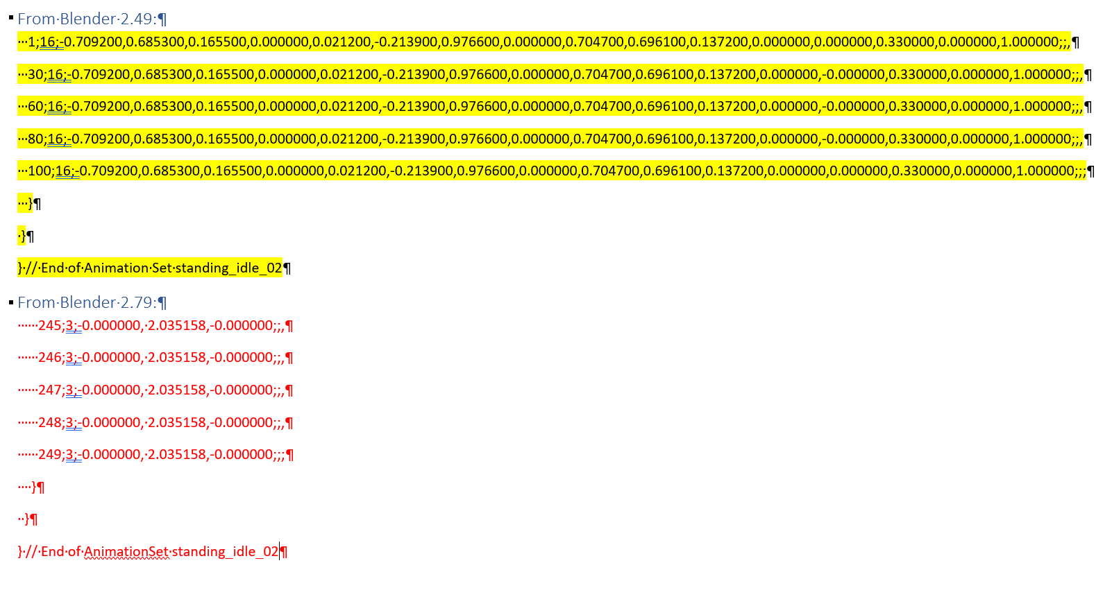
Could be worth further investigation in case this properly separates the two blocks in a way that allows Object Editor to use them. See any hierarchy of anims in adam_anim_idle_and_running_thesis_279 - Copy.txt
It begins like this:
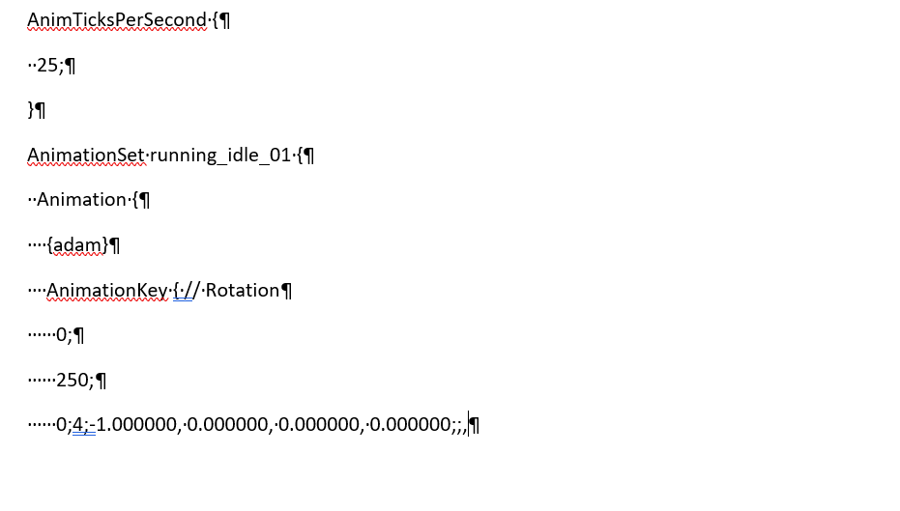
Compared to the one created in 2.49, which begins
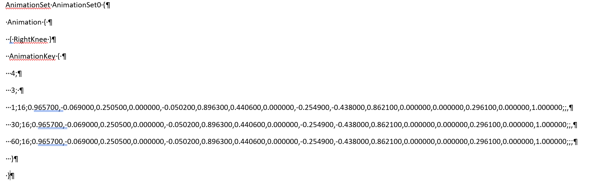
So, the version in 2.79 simply states the name of the whole frame before it instead of the name of the vertex group, starts using four spaces instead of three, and places the AnimTicksPerSecond value in front of the animation block rather than at the start of the whole thing. Note that there was no success in actually showing that 2.79 even manifested anything other than one animation (such an issue was disguised earlier by my copying of the same animation, rather than making distinct animations to see whether the Object Editor could even recognise them in the best scenario)

Infantry orientation wrong
Compared to the original soldiers of the game, the soldiers being made are oriented wrong; they need to have the y axis as up, as originally devised

Long combined animation and exporting from existing track as solution
As trialled today, it is possible to use the “export from track” option to isolate part of a larger animation, so it should be possible to create a series of animations in a single track. They can then be isolated and used for a specific animation loop or movement by selecting their “keys” and selecting OK?
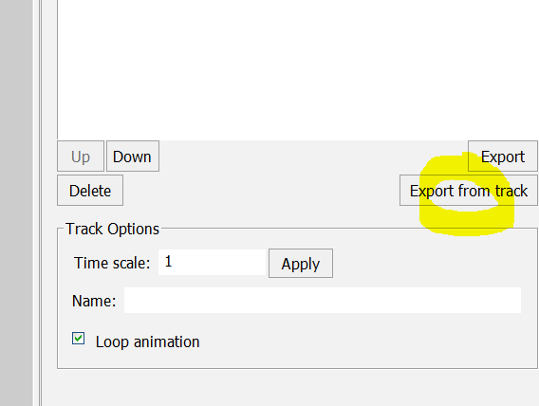
…
(Somewhat incorrect interpretation):
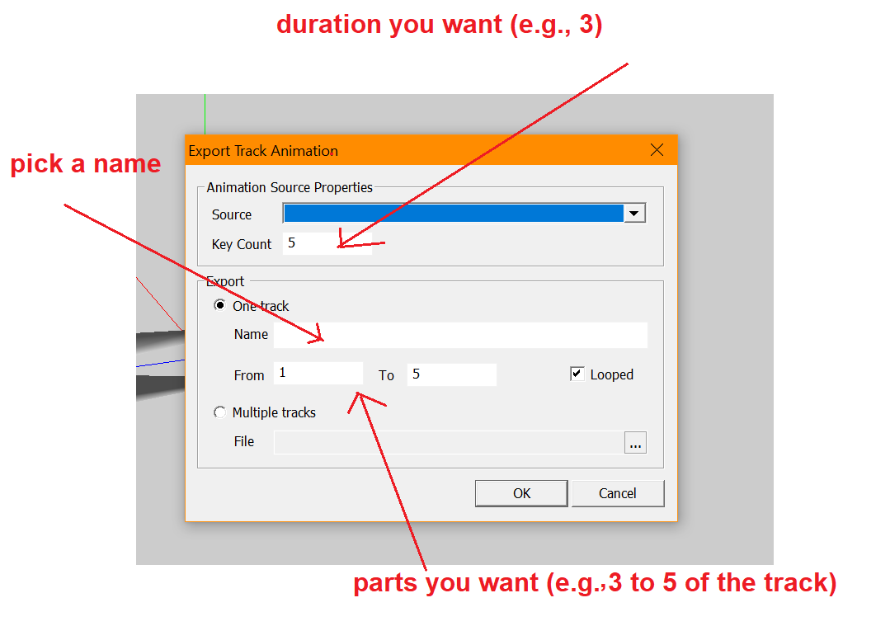
A different interpretation (still wrong, confuses frames and keys):
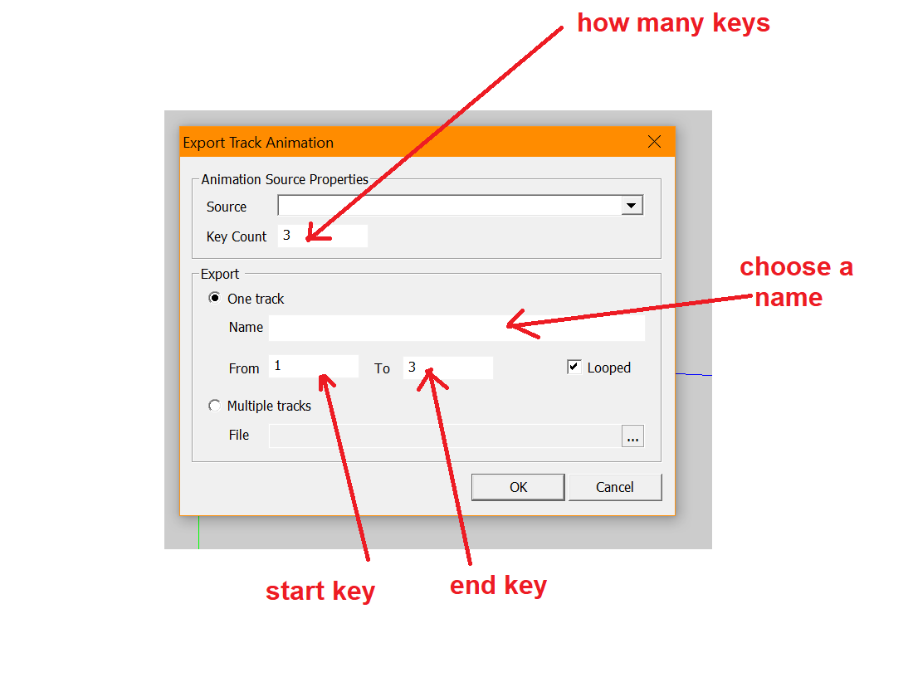
With this option, it seems that however many “keys” are in your animation will be detected. The above example is created from a Blender 2.49 animation with only 3 keys:
Based on this, you hypothetically could include many keys in your animation and then select them to create each part (to this end, imagine that your Blender character can be used like an actor, performing all his animated movements in sequence, while you should write down the key numbers for each movement so you can later specify them using the above method).
IGNORE THE ABOVE, this method actually works:
Go back to the section “Getting anims into Object Editor” and then do this instead:
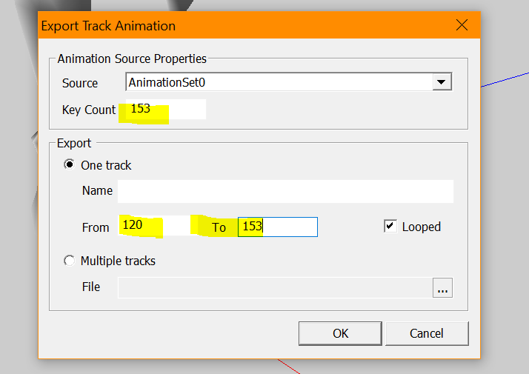
Here, the “key count” refers to every point frame in the animation in Blender (not just the keys), whereas the part in the above example (120 To 153) represents the part of the track (consistent with Blender) where the character does a running loop. When this method is used, a seamless animation seems to be possible.
Further, you can change the speed of the resulting animations here, which could be very useful for tweaking soldiers who are shooting, so their animation movements match the weapon particles and sounds in the gameplay:
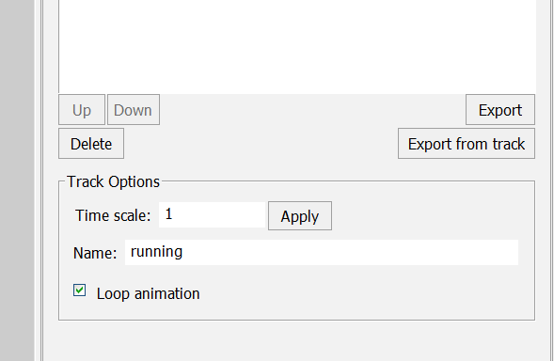
After saving the model, you lose access to any animations you did not extract using the above method, including the long stream of animations you created. You recover this stream of animations back, by using Files > Open X Model and selecting your directx file again, which will make your long track (e.g. AnimationSet0) available again for you to specify another animation from.
REVISION: the above method of opening the DirectX file again is the best way to make another animation, even a variation of another, as fresh animation selections taken from it are the most stable loops
Further: it should be possible in fact to import specific new animations by making new directx files where the new animation is your active one, then loading your directx file while you have your working model file open, which shall make the directx file become the source of your animations when using the already established above methods?
Test: in fact, you can only do so with the same x model as you used for your file – however, you can overwrite that x file while working on your model as many times as you want, specifying each animation by making it active as you go. So your workflow can be like this:
- Create your animations as you would in Blender 2.49
- Create your directx file
- Generate the model with only the one (active) animation, extracted using the “Export Track Animation” way in the Object Editor
- Then, while you still have your model open in the Object Editor, go back to Blender. Change your active animation in Blender to the next animation and create your x file again (keep its name the same and overwrite it).
- Go back to your model in the Object Editor, open your x file again while you still have your model open, then select your animation again from the “Export Track Animation” option.
- Your animation will be a different one, as from your latest Directx file save
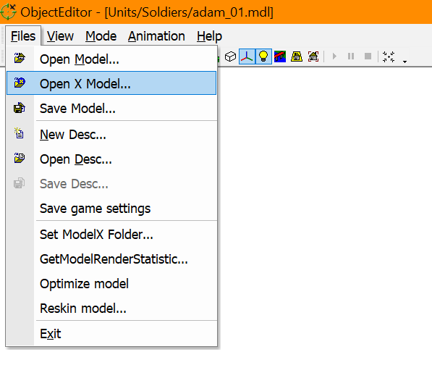
Another version of step 5:
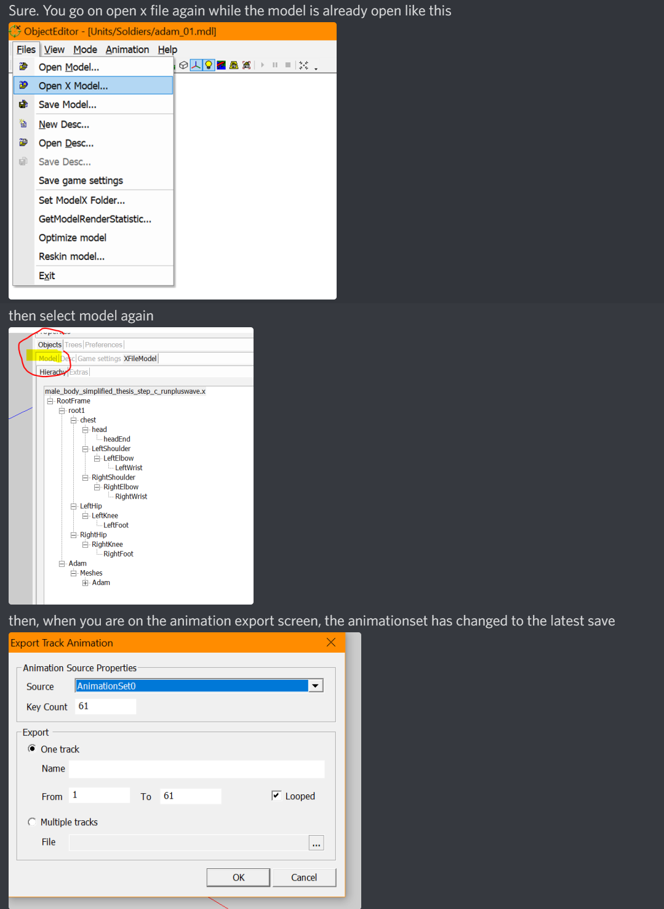
Note that the above methods seem to stop working if you close your model or the application crashes, so getting all required animations into the model in a single sitting is essential. In fact, it just seems unpredictable (often the Export button is greyed out where in other cases it is not).
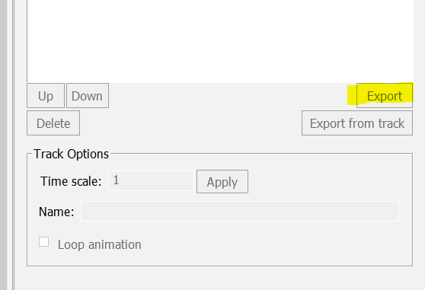
NEW: Don’t bother, just use the original method of all animations in one, and specify the desired frames as that seemed to be more reliable.
Note: Other methods may also exist, such as editing the directx file so that the Object Editor can understand where to get the different anims (see “pak_38 – Copy.txt” as sent from Discord as an example directx file with an applicable animation contained in it.

Death animation problem
When a soldier dies, the root vertices have to fall to the ground. With my present model, a death animation failed because rotating the root resulted in the whole armature rotating, affecting all the other animations once it was attempted. For the original game’s models, though, the root bone can change position in animations without affecting all the other animations. The problem may be fixed by using the whole timeline approach to the animations.

Tests of infantry as in-game objects needed
Some series of tests is needed next, to make sure the resulting infantry work in the game.
If infantry function and further testing is not needed, then it will be possible to return to the issue of making better animations, and finally create two fully animated human figures to settle the issue finally

Making a figure conform to the game
We see that not only does the hierarchy have a particular structure and naming convention for infantry in the game, but the animations have specific names. Many are specified even for soldiers or figures that should not need them, with “civilian_01” being a useful example. This probably means the game needs to read these animations, so they must be written right and must conform to the original game!
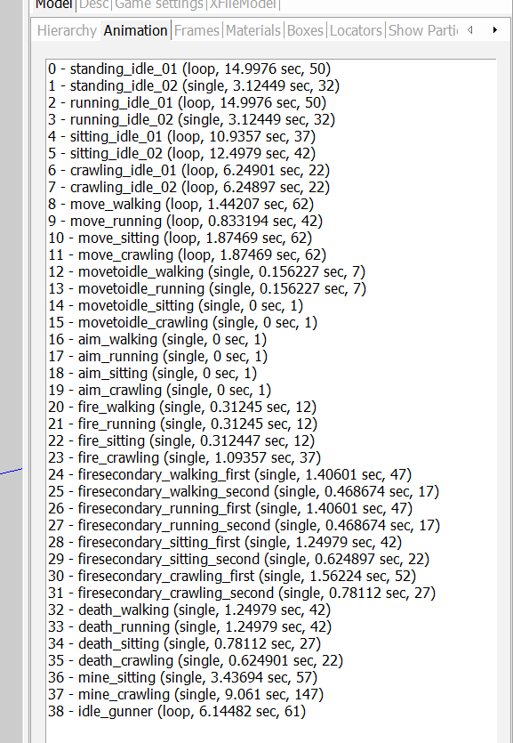
These animations are most likely essential, whereas the naming of the hierarchy may not be essential (further: tests show that the skeleton and parts can be named whatever you want, and extra bones/limbs work with any name)
Result:
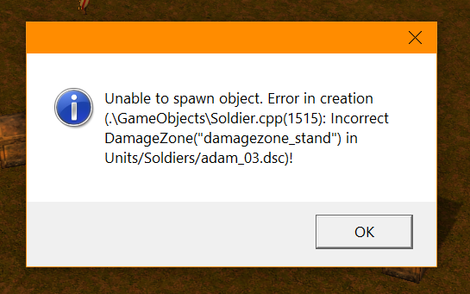
Correction applied: damage zones added based on civilian_01
Result:
Successful creation of infantry

Missing frames using the long animation track method for animations
When all the animations are back-to-back (e.g., it reverts to idle almost immediately and/or the next animation starts) it complicates the selection of the desired track especially when a single frame is vital to the soldier looking correct. Try to have the character stay still for a number of frames showing essential poses, such as a death pose, and also stay still for a number of frames when firing the weapon, while the gun direction should also align almost completely with the x axis (red) when shooting, even if the character model has to do a lot of movement to line his weapon up (otherwise, he won’t look like he is aiming at the target)

Infantry weapons
When adding firing points to soldiers (where the muzzle flash will happen in the game), the body of infantry will contort. However, this is because all the vertex groups are moved into the same place/orientation for you to apply the transform to the firing locator. You will need to spot the “barrel” or butt of the gun in the pile and apply the firing point to it, with the red line pointing where the gun will shoot. Having guns as distinct objects may have helped the developers to avoid problems with this, as they are unaffected by this feature. In my example, I created a cyborg with a gun melded to his arm, so this was more difficult and the gun had to be spotted in the pile.
Added: the weapon can be separated by creating another frame for it, e.g.
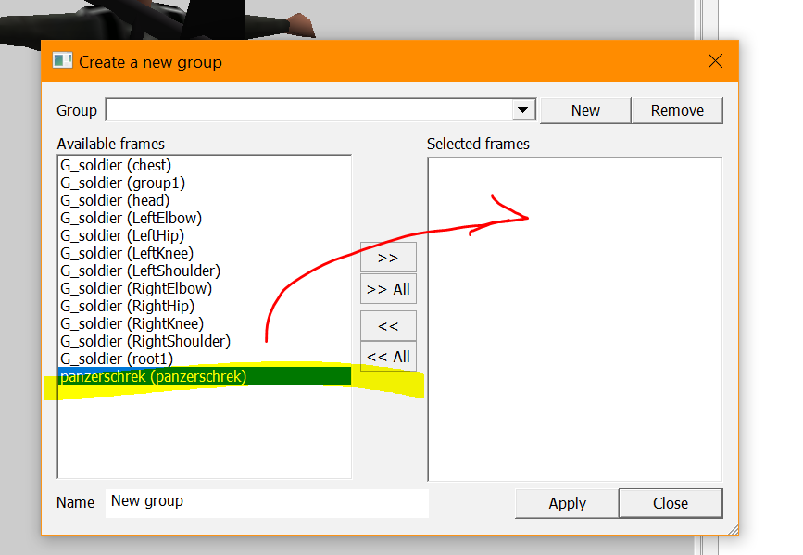
You can then tick it and untick everything else to clearly see it and apply the locators to it
This really seems to be all the developers did. How they got it to be a distinct object (not reading as G_soldier) is not clear because the name G_soldier would denote everything in the object if exported from Blender, and the panzerschrek would definitely be part of the soldier object because it is parented to parts of it via the skeleton. Fortunately, the result seems unaffected. Weapons can simply be created as bones not tied to other bones but still parented to them. The weapon is parented to the chest bone but not joined to it (that means it can move wherever it wants as if it is not a bone, but is still tethered to the chest so it can’t wander away). To do that in Blender, just make two bones one after the other, so the first is parented to the chest and the second is parented to the first, and then delete the first one so your bone isn’t connected to the skeleton but is still parented to the chest (you will see a line connecting it)
Your soldier’s weapon firing locator must use the right “bone” (in my case the cyborg’s arm, in other cases a weapon), study existing infantry examples and copy from them.
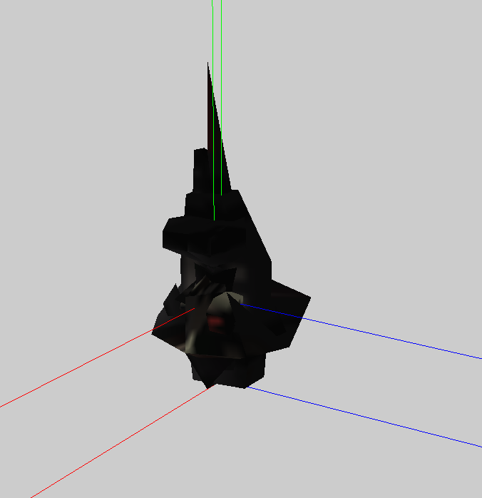
It is also VITAL that you copy the other firing locators used by another example of infantry in the original game – start out by using an existing dsc file for your first soldier, just as you would when making the dsc file for your first tank. The exact nature of these locators is hard to understand and not necessary to study because they can just be copied by us, but the game needs them. Copy them precisely.
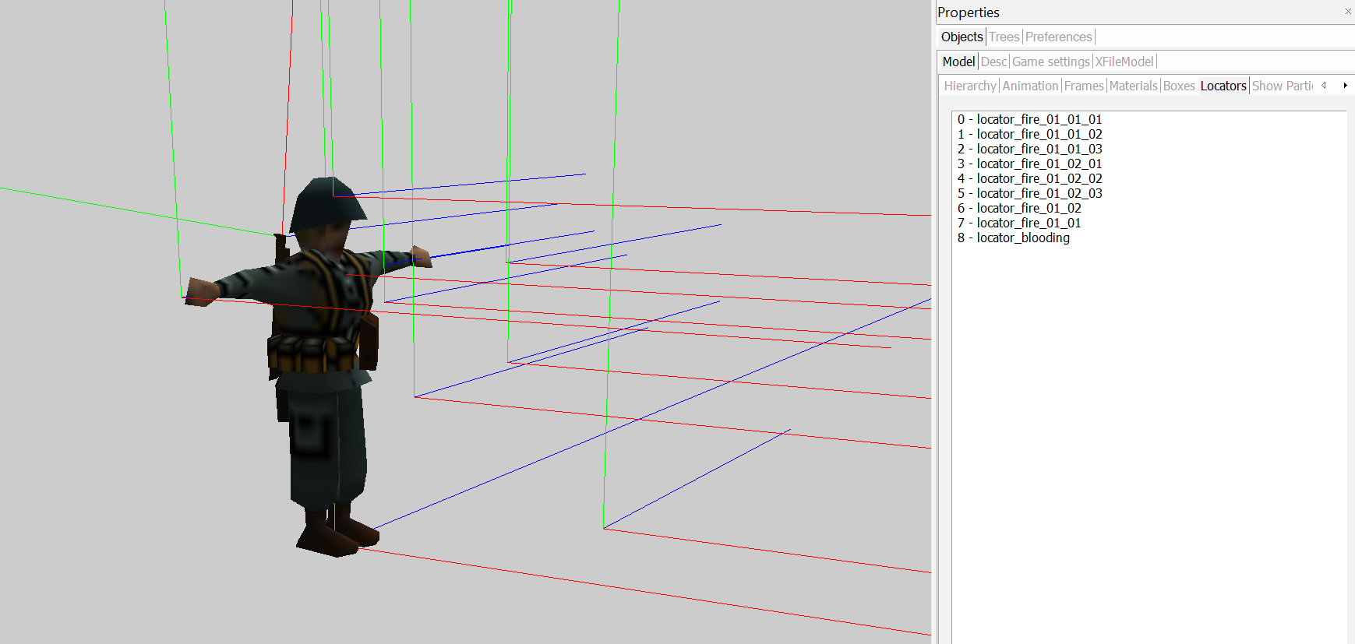

Infantry flip problem
You will find that your model will flip if you are using the export options from Blender that were used in the above notes, if you go back.
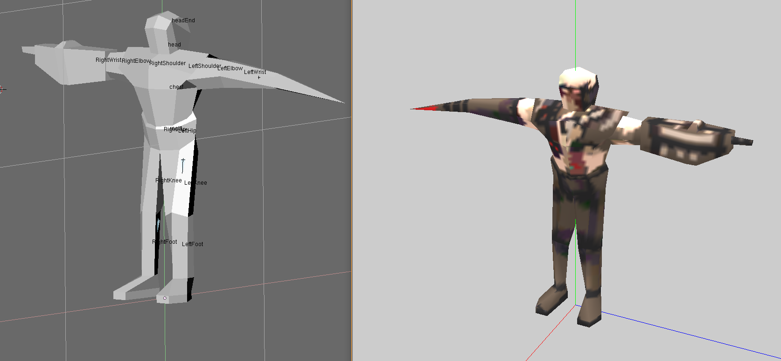
This is likely due to flipping on the z axis, which was used during export options in our earlier notes:
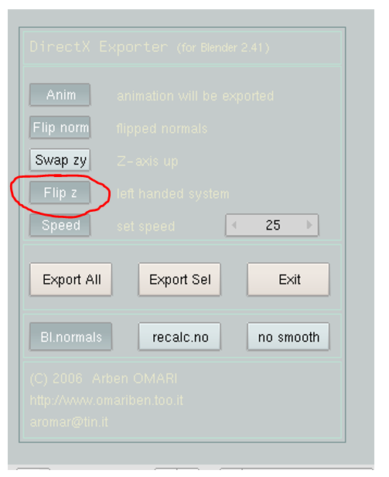
A further test revealed that the directx export and model generation on OE will work fine without the above settings, perhaps making these below the best real infantry settings when exporting:
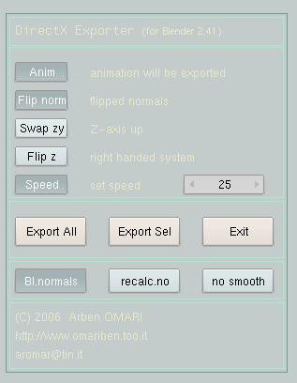

Infantry weapon particles and firing locator trouble?
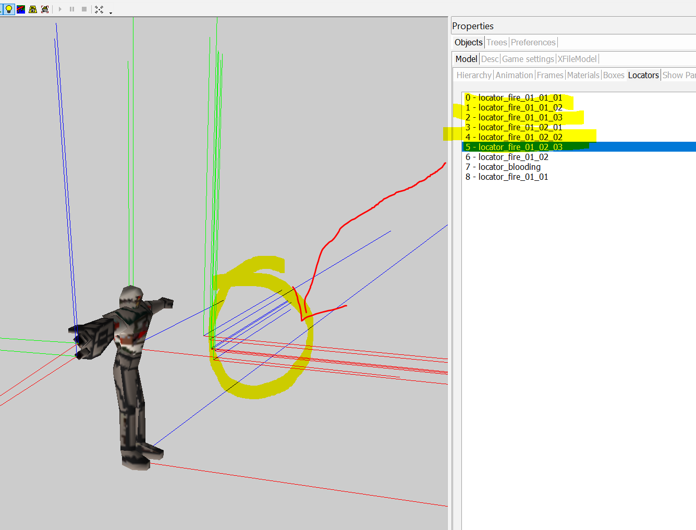
Make sure all these firing locators are above ground level and in front of your character. They establish the “level” at which the gun particle effect will generate (in the above example, the cyborg doesn’t crouch or take a prone position, so his are all high up) – if your soldier takes a prone position, some locators will need to be low. You may have to check an existing infantry example that your desc for the unit will copy its locators from, to see which locators are in the prone height and assign them in the equivalent way with your desc. The easiest way is just to copy every attribute of the soldiers from the game closely, in which case problems like the above will then only happen with non-human or large units – for the latter examples, you can put your character into the appropriate animation in the Object Editor before moving the height for the firing locator to where it needs to be to match the unit’s behaviour

Making soldiers more realistic or “fuller”
In making these notes, early versions of soldiers were quite robotic. They did not perform many extreme organic movements like the kind of crouching, crawling and aiming with a weapon of the soldiers in the original game. When that is attempted using the above simple techniques, the soldiers may in fact appear to have joints that go “flat” as if the soldiers are made of paper, which can look bad. You want the soldiers to look muscular, not like are made of balloons or paper cut-outs. To defeat this problem, you may have to improvise and keep testing your soldier in Blender and in the Object Editor until you are satisfied with it.
When you uncouple the joints by giving each section of limb its own vertices, the mesh tears apart and the soldiers look like they have no knees. It could not only be a bad problem with more realistic soldiers, but also with larger robots (if they can be made), as the player will be able to see inside or through their mesh. The original game once again reveals clues about a solution:
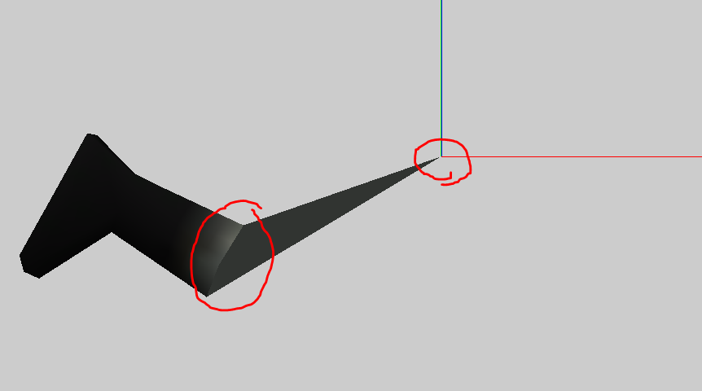
In this German boot, we see that the vertices at its top all converge at one point or one vertex. Because that point belongs to another vertex group, though, it moves to position 0, 0, 0 in the Object Editor
If we take a look at the next limb in this leg, the upper leg (it is labelled knee in the Object Editor but can also be foot in other examples), we see this:
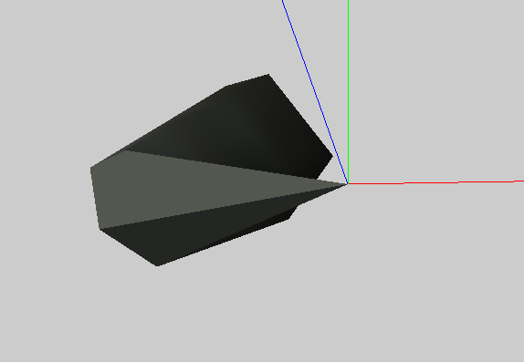
Clearly, the vertex that is warping to the position 0, 0, 0 had a vertex that leads to the “knee” grouping and the rest of this group had its own mesh (not even connected to the “root” at all)
Next, we should look at the root:
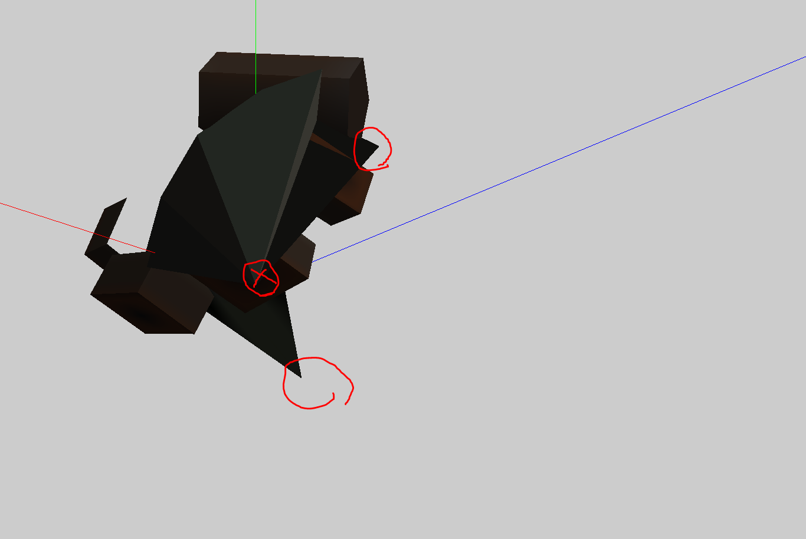
The area marked with an (x) indicates where the mesh would connect to another point (the chest presumably); however, other parts appear to just exist as if additional faces were needed to cover something up
These faces seem to exist just to surreptitiously stick out and cover up “gaps” otherwise appearing in the character’s posterior; it seems to be just an improvised solution by the developers
You can keep experimenting and arrive at whatever solution you want. An additional way to prevent gaps forming (in a more organic character) can simply be to add more segments
The middle part of the character may bend badly if the “root” or main parent bone in the skeleton’s centre is not oriented in its own angle neutral to the other child bones (e.g., it should be neutral relative to the hips and chest angle, if the character is hunching with the chest and hips oriented towards where the character is going)
What we can learn from the above is that in order to make elbows and knees look better, it is best to let the two segments of each limb (or their vertex groups) overlap somewhat but for the parent segment to connect via a single vertex to the centre of the child segment (e.g., the knee of a character will include a single middle vertex that warps the texture of the foot vertex group “into” it, to seal the joint or at least improve the appearance of the joint

Save making the UV map/skin until last
When making a realistic soldier, effort to paint the texture on the character should be handled only after an appropriate animated character is made in full. This is because you may find the mesh deforming in ways that require more faces to be added, as in the above findings. In those cases, you need to apply colours after all the faces are there. You will also need to paint different the weapons for the soldier and give different soldier types different weapons, so having weapons placed in your blend file and deleting the unneeded weapons before export to .x is recommended
In addition, you should make the various neutral animations before making animations specific to the weapon, as you can then save more files for developing the different soldier types with different weapons. Neutral animations (study the original characters from the game) are –
move_sitting
move_crawling
all deaths (walking, running, crawling)
all cargo idle anims
all cure anims
the refuel loop
… when making these, you might want to ensure that the character has a hand free as if it is holding something, as this can then be made to be holding a gun or balancing a bazooka on his shoulder for the different soldier types (alternatively, you could just place the bone for the gun on the character’s back or belt when it is not in use)

Lighting issue
When new soldiers are created according to the established way, light will land on the soldier from the opposite direction to where it is meant to come from:
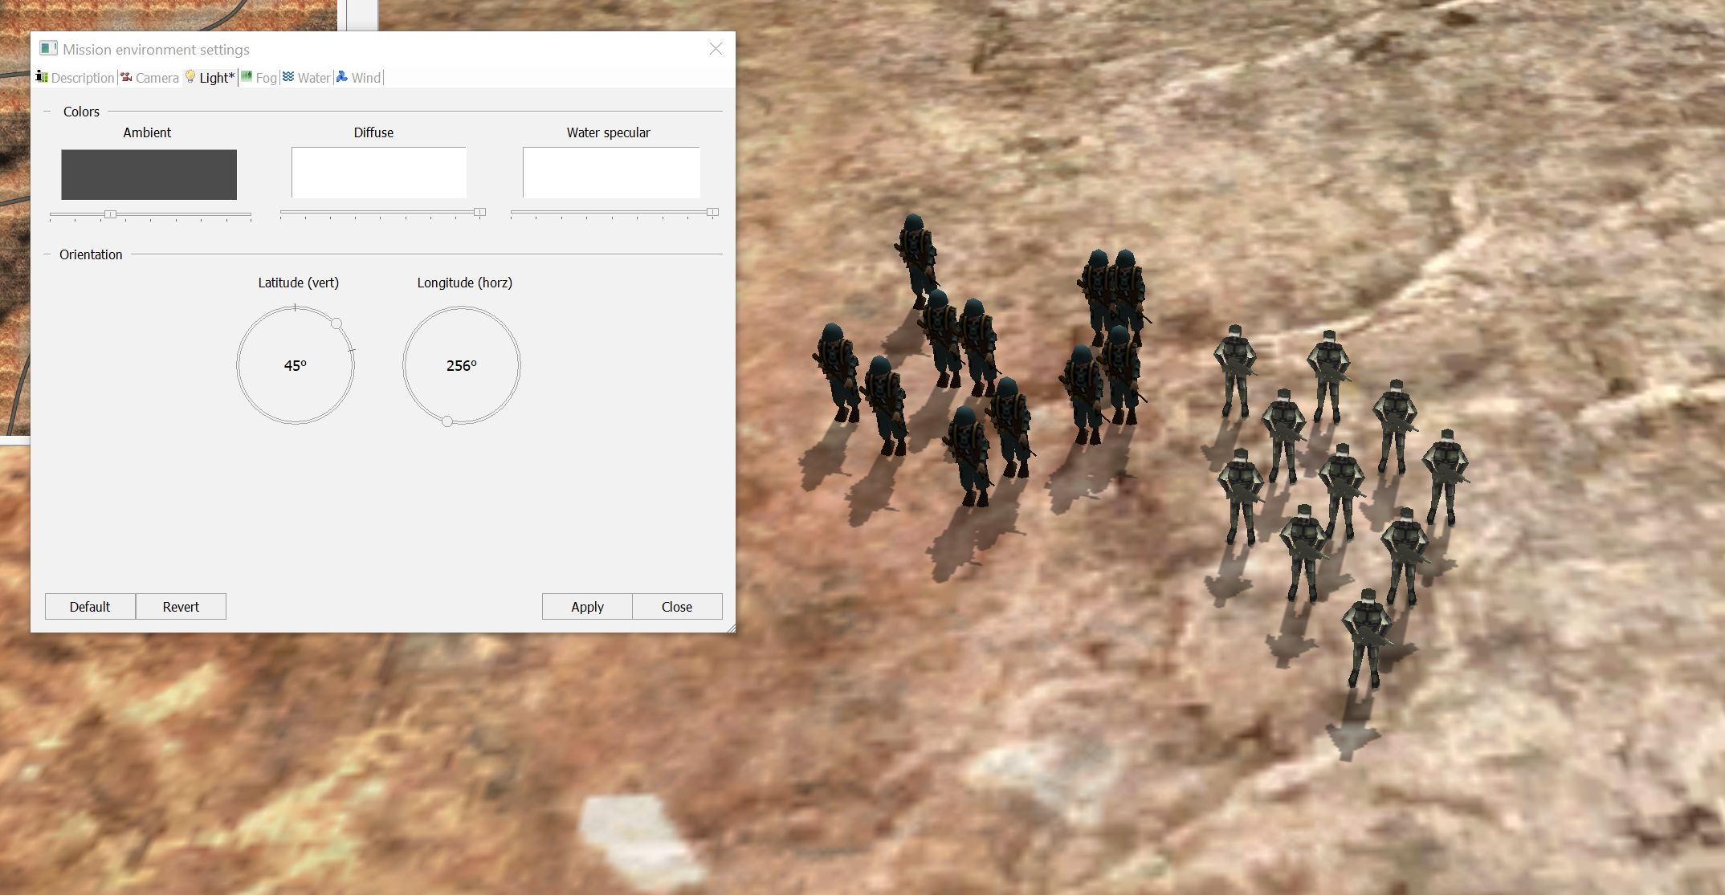

Improvised solutions
There may not be a way out of the problem itself. Arguably, the infantry do not look as good with the shadows on them anyway (one complaint of people was that they can look like stick figures); ambient lighting settings can make soldiers look fuller and more colourful from different sides, and setting an emissive value in the OE may also help:
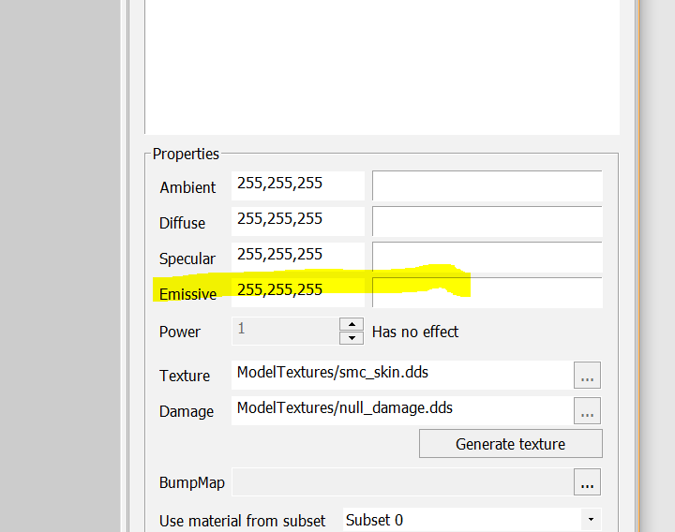
Result so far:
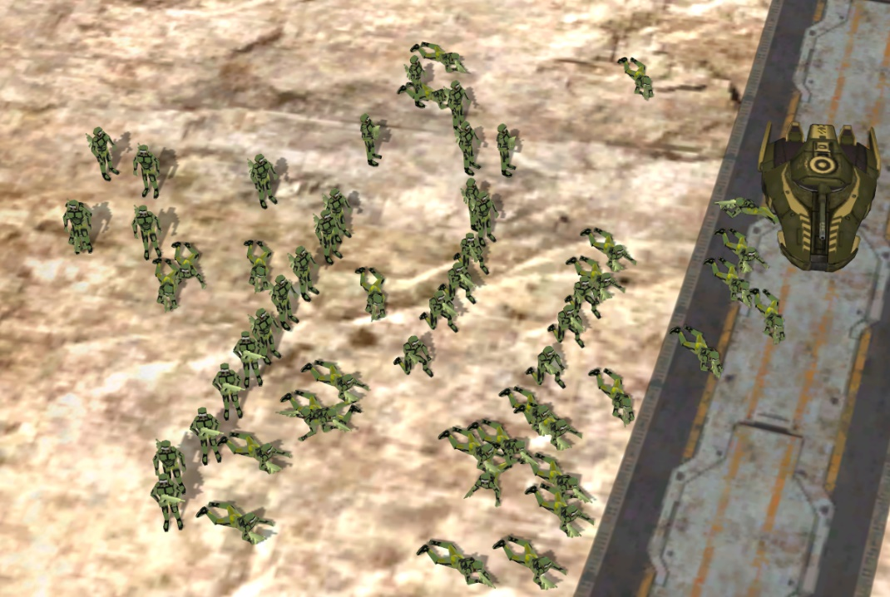

Further study of the lighting issue
Machine gun is not affected
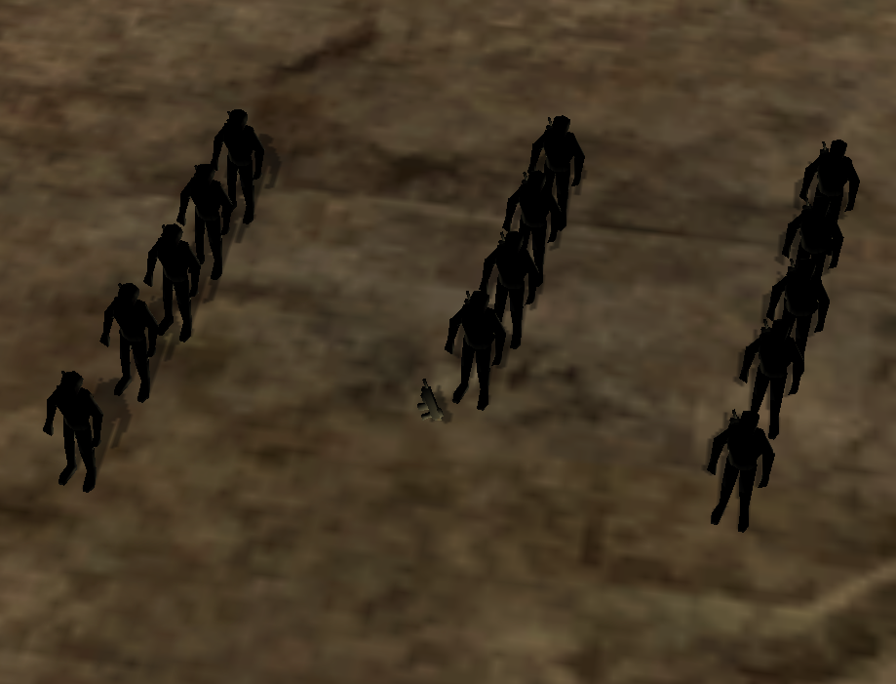
Looking at this change of settings
Do NOT use “Flip normal” -
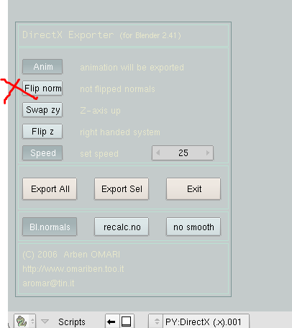
Difference in Object Editor –
Left: removed the “flipped normals” from export options
Right: used the “flipped normals” option in export options
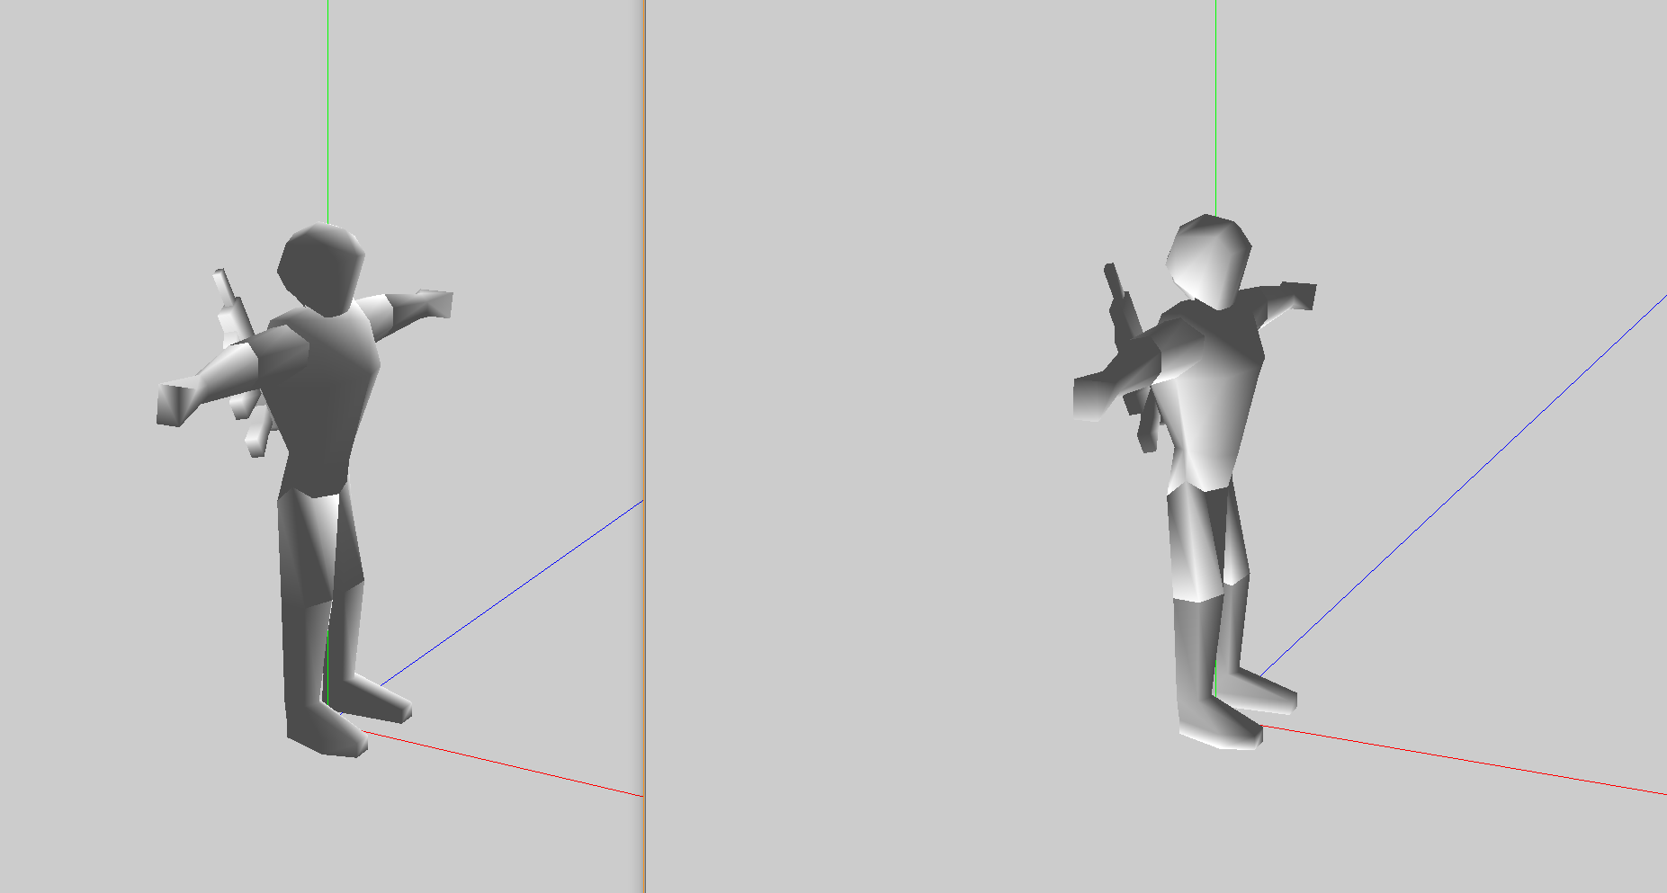
German soldier in original game
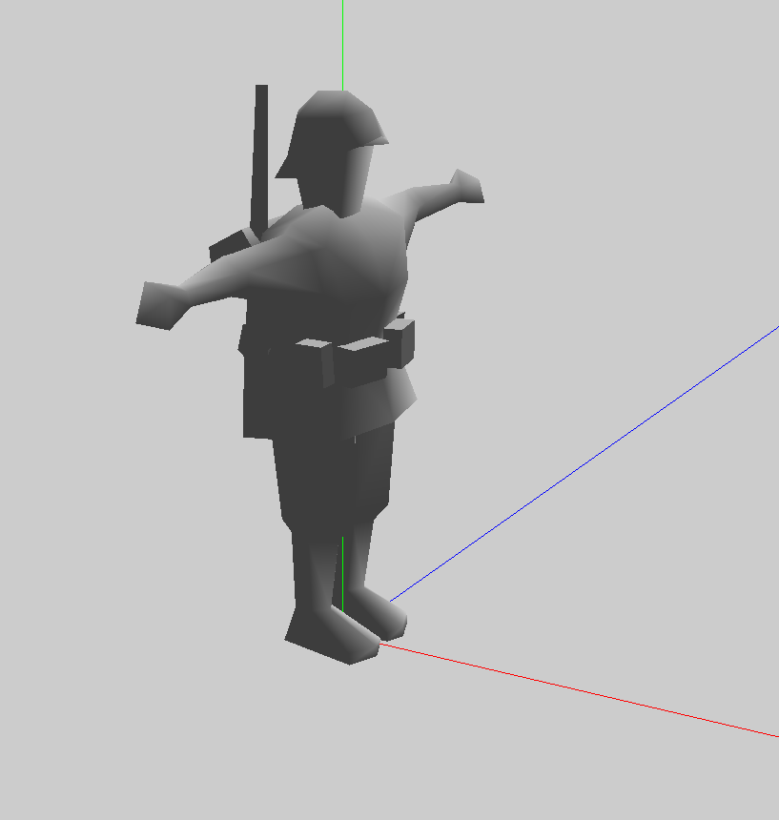

A good workflow
In the original game, many animations are shared between different types of soldiers. This is a good approach to take, to save time. Try making one human model in Blender and a skeleton with lots of good animations. Then you can keep starting your work with this model, editing it differently for each soldier type and exporting it however many times you want, changing the size of the soldier and skeleton, changing weapons and animations just a small amount and exporting to directx again to help make another type of soldier. The only very long process should be to make a good starting template on Blender that you can keep reusing to make all your other soldiers, with only small adjustments each time you export a soldier.
If your goal is just to make human troops like the original game, this will not be difficult and you will get very fast at it. If you want to make strange monsters and robots, it will probably take more effort, but you can still do it!

